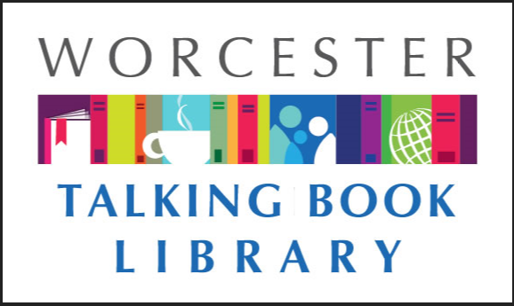
TALKING BOOKLET

Fall 2021 * Worcester Talking Book Library Newsletter

After a wet, humid summer, we are happy to see fall is coming. A little cool air and hot cider is exactly what we want with us when we curl up with a good book. Reading anything good? Need a recommendation? Let us know! We are happy to help-and always looking for some good reads ourselves.
If you would prefer to listen to this newsletter in audio, call our Dial-A-Story line 508-552-3456 and select menu option #1. For other formats such as braille and email, please reach out to us at talkbook@mywpl.org or 508-799-1730, and we will make sure you get what you need as it becomes available.

COME SEE OUR NEWLY RENNOVATED SPACE!

After nearly two years of work, the Main Branch of the Worcester Public Library is rennovated. We had our official ribbon cutting on August 12 at 4 p.m. and invited the community to see the new space. We’ve added a new door to the Franklin Street side of the building which opens into the warm and inviting Newspapers and Magazines section which has study rooms and Readers Digest in large type. There is an innovation lab complete with 3-D printers and sewing machines, and other tools and the tutorials on how to use them. There is more room for browsing, studying or just visiting. One of the most exciting features is our brand new children’s space complete with a fun rocket ship in the middle of the room.
While we’re really excited about the whole library, we are most excited about the new Talking Book Library room. The new paint and carpeting have spruced up our appearance. Our computers have desks which are accessabile and can move to various heights. We have a small study room for folks to book and utilize. We’ve also added a hearing loop table to this room. This will allow for persons with hearing impairments to connect t-coil hearing aids to the table which contain microphones to amplify speech. We’re hoping to see our patrons utilizing our space and look forward to welcoming you.
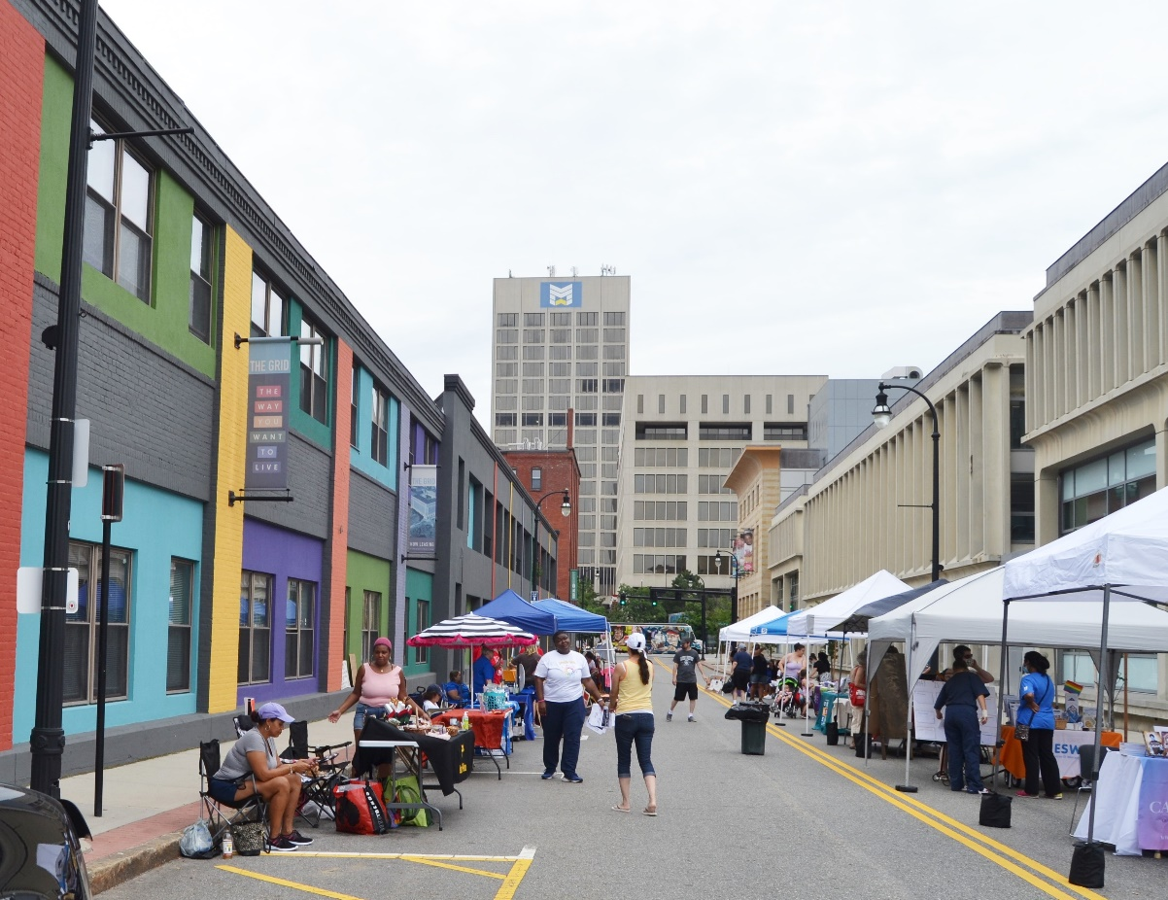
(Above: a photo of Salem Street adjacent to the library, which had been closed off to accommodate vendors and events celebrating the new and impoved WPL!)

To celebrate, WPL hosted a neighborhood block party on August 14th. We had food trucks, vendors, a petting zoo, baloon animals, face painting, and more. It was a terrific day with a great turnout. The rennovation and pandemic have meant we’ve missed seeing a lot of our patrons. While we aren’t in the clear yet, we’re happy that people are coming back. Please do note that if you come to visit us, masks are required. If you have forgotten yours, we will be able to accommodate and give you one.

ACESSIBILITY TRAINING IS COMING BACK

You’ve asked; and we’ve listened! In person accessibility training is coming back to the library. Donna and Nona are going to be offering monthly workshops. Classes will be monthly on Thursdays at 10 a.m. at the Main Branch of WPL. The first four sessions and dates are as follows:

October 21: How to use the App Store and downloading Apps
November 18: Basic use of the BARD App
December 16: Basic use of the Mail App

January 20: Using Siri as your personal assistant

All courses are free. In addition, Donna and Nona offer one on one accessibility training on Smartphones and computers, which are also free. For more information, call us at 508-799-1730.

ENHANCED SECURITY TO BARD
BARD has increased its security measures to keep patrons safe. It’s important to log into your account every six months to prevent it from going inactive. If the account does go inactive, you will be locked out of your account. Don’t worry! We can always reactivate you. Just give us a call at 508-799-1730.

COVID-19 INFORMATION
There can be a lot of misleading and confusing information on COVID-19 so we want our patrons to know there are reliable ways to keep informed. Some of our favorites are as follows:
Statewide information on COVID-19 can be found at www.mass.gov/covid19 or by calling 211.
In the city of Worcester, resources are available at www.worcesterma.gov/coronavirus or by calling 508-799-1019.
Some cities and towns are offering free COVID-19 tests for Massachusetts residents. For information on locations and scheduling please visit www.mass.gov/info-details/stop-the-spread.
To receive up to date texts about COVID-19 on your cell phone from the Commonwealth of Massachusetts’ coronavirus response team, text 888-777.
The state’s crisis counseling assistance program can be reached at 888-215-4920.
The Massachusetts Nursing Home Family Resource line is 617-660-5399.

VACCINE CLINICS HELD AT THE LIBRARY

The Worcester Public Library is now hosting vaccine clinics at the Main Branch. At this time, clinics run Wednesdays from 11 a.m to 7 p. m. and Saturdays 11 a.m. to 5 p.m. Clinics are operated by the Worcester Department of Health and Human Services and are open to all persons regardless of what town the live in. Anyone 12 and over is eligible. Johnson and Johnson, Moderna, and Pfizer vaccines are available. All vaccines are free regardless of insurance status.

RECOMMENDED READS
Looking for something to read? We always have ideas! Feel free to call us at any time for some suggestions based on your interests.

Bagels Bumf & Buses: A Day in the Life of the English Language. By Simon Horobin. DB 99366
An exploration of the origins, histories, and evolutions of common English words used over the course of daily activities, including getting up, going to work, eating meals, and more. 2019.
The Beauty in Breaking. By Michele Harper. DB 99692
A female, African American emergency room physician--in a profession that is overwhelmingly male and white--explains how each of us is broken--physically, emotionally, psychically. How we recognize those breaks, how we try to mend them, and where we go from there are all crucial parts of the healing process. Unrated. Commercial audiobook. 2020.
A Credible Threat. By J.A. Jance. DB 99919, LT 28446
Years after her son's fatal overdose, a grieving mother learns that he was abused by a priest. Seeking vengeance, she targets Archbishop Francis Gillespie. When his driver is killed and the priest severely injured, Gillespie's friend Ali Reynolds forms an uneasy alliance with a Phoenix homicide cop to prevent another attack. Unrated. Commercial audiobook. 2020.
Entangled life: how fungi make our worlds, change our minds & shape our futures. By Merlin Sheldrake. DB 99961
Biologist shares the rarely understood lives of fungi, a kingdom of lifeforms which is billions of years old. Topics covered include reproductive cycles, evolution, ways fungi affect their environments, and uses in a variety of fields. Unrated. Commercial audiobook. 2020.
The Forgotten Soldier. By Guy Sajer. DB 100157
An account of the horrors of World War II on the eastern front through the eyes of the author as a young soldier in the elite Gross Deutschland Division of Germany's army. Unrated. Commercial audiobook. 2017.
Garlic, Mint and Sweet Basil. By Jean-Claude Izzo. DB 100042
Collection of three books of essays exploring the Mediterranean region by late journalist and author of French noir fiction. Discusses the food, culture, and locations in which Izzo grew up. In "Here, My Darling, Taste This," he describes exploring Marseilles' markets. Translated from the original French edition. 2013.
How We Disappeared. By Jing-Jing Lee. DB 99773
2000. After the loss of her husband, Wang Di reflects on everything she failed to tell him, and slowly confesses secrets to her twelve-year-old grandson, Kevin. In 1942 Singapore, seventeen-year-old Wang Di is taken by invading Japanese troops to work as a comfort woman. Unrated. Commercial audiobook. 2019.
The Last Negroes at Harvard : The Class of 1963 and the Eighteen Young Men Who Changed Harvard Forever. By Kent Garrett. DB 99755
In 1959, Garrett and seventeen other young black men entered Harvard University as freshmen. Examine their experiences over their four years there as the civil rights movement gained momentum, and the ways those experiences shaped them later in life. Strong language. Commercial audiobook. 2020.
Murder Beyond the Grave. By James Patterson. DB 100126, LT 24416
Two true-crime cases from Discovery's Murder Is Forever. In the title entry, Stephen Small has a Ferrari, fancy house, loving wife, and three boys. But what he needs is enough air to breathe. Kidnapped, buried in a box, and held for ransom, Stephen has forty-eight hours of oxygen. Also includes Murder in Paradise. Unrated. Commercial audiobook. 2018.
Tuesday Mooney Talks to Ghosts. By Kate Racculia. DB 97793, LT 28035
When Vincent Pryce, Boston's most eccentric billionaire, dies, he leaves behind an epic treasure hunt through the city, with clues inspired by his hero, Edgar Allan Poe. Tuesday Mooney is forced out of her shell when she works with a motley crew to join the hunt for Pryce's fortune. Strong language. 2019.
Wrath of Poseidon. By Clive Cussler. DB 99862, LT 28428
Ten years ago, Sam Fargo and Remi Longstreet unsuccessfully hunted the legendary riches stolen from the Persian King Croesus in 546 B.C. Now someone they helped put in prison is out and determined to get the treasure and kill the now-married Sam and Remi Fargo. Unrated. Commercial audiobook. 2020.
Welcome to the Pine Away Motel and Cabins. By Katarina Bivald. DB 98111, LT 27459
After motel manager Henny dies in an accident, she can't bear to leave the people she loves behind. Even dead, Henny is determined to help her friends rediscover the happiness they once knew. To help them move forward, Henny will have to look back. Unrated. Commercial audiobook. 2020.
Did you know that we now have our own application? The National Library Service for the Blind and Print disabled has given us their blessing and approved our design. We’ll be distributing them to potential new patrons. If you know of anyone who qualifies for our services send them our way!

WPL PROGRAMS ARE BACK
We are excited to welcome you back into the building for in person programming! In addition to the accessibility workshops mentioned earlier, we have some other wonderful events we would like to invite you to:

Financial Wellness Workshops with Anne Joyce of Berkshire Bank
Tuesdays, Oct. 12, Nov. 9, 6 - 7 p.m.
Banx Room
Oct. 12: Identity Theft
Nov. 9: Understanding Your Credit Report & Score
Registration required. Call 508-799-1655 ext. 3

The Grip: The 1918 Pandemic and a City Under Siege
Saturday, Oct. 23, 11 a.m. - 12 p.m. First Floor Ellipse
Join historians Shawn Driscoll and Linda Hixon to hear how Worcester struggled as over 1,000 people died in just a little over six months before the first modern pandemic finally ended.

Nutrition Class with Judy Palken, Registered Dietitian
Saturdays, Sept. 11, Oct. 9, Nov. 13, 2:30 - 3:30 p.m.
First Floor Computer Lab
Sept. 11: Diabetes - Prevent, Treat, and Eat
Oct. 9: Food and Mood
Nov. 13: Thanksgiving Resolutions
Registration required. Call 508-799-1655 ext. 3

Want To Write A Novel? Here’s All You Need To Know with Hank Phillippi Ryan
Saturday, Nov. 20, 2:30 - 3:30 p.m. Zoom
You will leave this class with a plan for your book, a list of absolute
necessities, and even some inspiration. Registration required. Call 508-799-1655 ext. 3

WPL HorrorFest 2021
Fridays in October, 2:30 - 3:30 p.m.
First Floor Computer Lab
Join us every Friday in October for a discussion about the horror genre.

CONTACT US!
The Talking Book Library is located inside the Worcester Public Library at 3 Salem Square, Worcester, MA. Call us at 508-799-1730 or email us at talkbook@mywpl.org. You can also like us on Facebook. We have a monthly email list as well that you can request to receive. We are open to the public for circulation and computer use, so please come by and say hello!
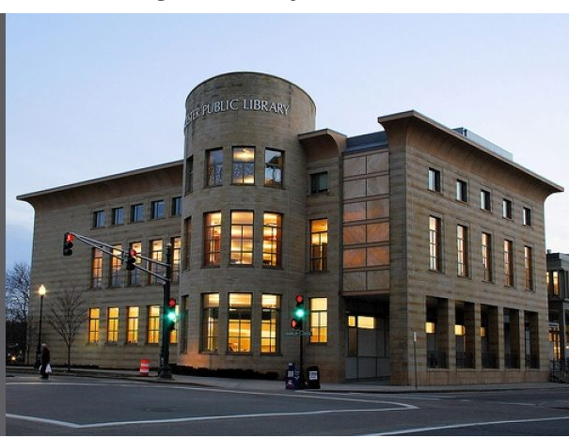

Current hours we are available by phone:
Monday-Saturday 9 a.m. - 5:30 p.m.
Current hours we are open to the public
Monday-Saturday
9 - 10:30 a.m.
11 a.m. - 12:30 p.m.
1 - 2:30 p.m.
3 - 4:30 p.m.

