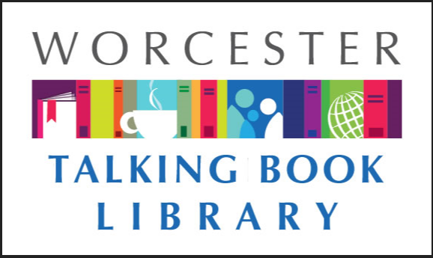
TALKING BOOKLET

Fall 2020 * Worcester Talking Book Library Newsletter

WE ARE BACK!
The Talking Book Library staff has some great news: we are back in the building and circulating books again! Due to the pandemic and orders from Governor Baker, we had to close our doors for a few weeks. However, we are delighted to tell you that while we are closed to the public, we are circulating items via mail. Please return all books you have finished reading, and get in touch with us about anything you’d like to request. You can reach us by phone, email, or even the mail! We’ve really missed our patrons and can’t wait to reconnect with you.
We are currently quarantining returned items for 72 hours. If you send something back and it is still showing up as checked out on your account, that’s why. TBL staff are taking necessary precautions to stop the spread of the coronavirus by practicing social distancing, wearing masks, and disenfecting surfaces in our work space. We are also staggering staffing and as a result might not be able to answer the phone as quickly as we’d like. Please do leave us a message if you get our answering machine so we can assist you.
If you know anyone who is missing reading because they are stuck at home, and they might qualify for our services, send them our way. We can provide information and mail out applications for them. We know a lot of folks are lonely in their homes right now and could really use a book to keep company.

COMPUTERS AVAILABLE AT WPL
Need to check your email or update your resume? Do you have to send a fax or copy a document? We can help! The main branch of the Worcester Public Library, where we are located, is open for computer use, copying, and faxing by appointment only. Appointments are for two hours. You can reserve online at www.mywpl.org or call us at 508-799-1730 for more information. Staff are wearing face covering and practicing social distancing, and patrons are requested to do the same.

FILL OUT THE CENSUS TODAY 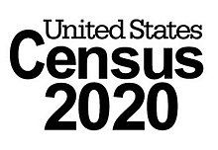

The 2020 census is still underway despite the pandemic. Completing the census is very important-it helps to decide where federal money needs to be allocated. This includes healthcare, Medicaid, and other important resources. All data collected is confidential and will not be shared with outside organizations.
Avoid scams: as a reminder, the census bureau will never ask you for your social security number, your bank account or credit card information, or request money or a donation. For more information call 1-833-MA1-2020 or visit 2020census.gov

CONSTRUCTION UPDATE 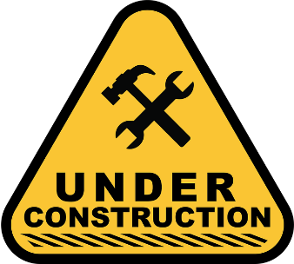
The renovation project has resumed! Workers have framed where the new front door will be and things are coming along nicely. In addition, we have vacated items and staff the periodicals section from the third floor with the hopes to begin to prepare the space for the new children’s room. Things are moving fast and we are excited, because it means we are getting closer to a newer TBL space for our patrons to enjoy.
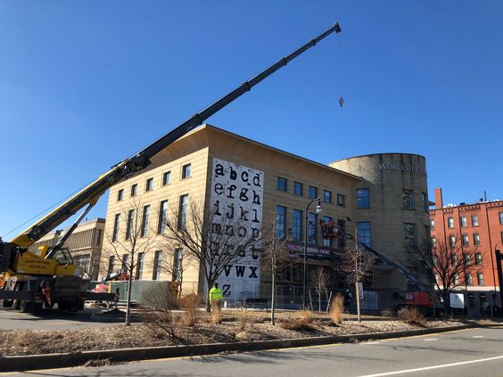
Above is a photo of the front of the Main Library. There is a crane out front and another large piece of equipment. They are using the machines to begin to take down the stones one by one where the new front door will go. There is a mural on the front of the building of the alphabet in a typewriter font that will be restored once the renovation is complete.

COVID INFORMATION
There can be a lot of misleading and confusing information on COVID19 out there, so we want our patrons to know there are reliable ways to keep informed. Some of our favorites are as followed:
Statewide information on COVID 19 can be found at www.mass.gov/covid19 or by calling 211
In the city of Worcester, resources are available at www.worcesterma.gov/coronavirus or by calling 508-799-1019
To receive up to date texts about COVID to your cell phone from the Commonwealth of Massachusetts’ coronavirus response team, text 888-777
The state’s crisis counseling assistance program can be reached at 888-215-4920
The Massachusetts Nursing Home Family Resource line is 617-660-5399

RECOMMENDED READS

Beep: Inside the Unseen World of Baseball for the Blind. By David Wanczyk DB90850 BR22265. A sportswriter examines beep baseball, a version of the sport played by the blind, in which the rules have been tweaked and the equipment made audible. The author travels the world to follow the sport, interviewing players and coaches while describing the action during the Beep Baseball World Series. Some strong language. 2018.
Bruce Lee: A Life. By Matthew Polly DB91770. Biography of famed martial artist and actor who died in 1973, at the age of thirty-two. Using interviews from Lee's family and friends, explores his years as a child star in Hong Kong, his start as a martial arts teacher, and his struggles as an Asian American actor in Hollywood. Unrated. Commercial audiobook. 2018.
Callaghen. By Louis L’Amour DB90625, BRC1495. The patrol's lieutenant is killed by Mohave Indians. But private Callaghen's leadership and desert survival skills save the rest of the men. After discovering a treasure map in the dead officer's belongings, Callaghen changes his plans and tests his mettle. Some violence and some strong language. 1972.
The Deceivers. By Alex Berenson DB91473, LT23655. The Russians don't just want to influence American elections--they want it all. Former CIA agent John Wells confronts a plot of astonishing audacity: an extraordinary confluence of sleeper cells, sniper teams, false flag operations, double agents high in the U. S. government--and a Russian plot to take over the government itself. Unrated. Commercial audiobook. 2018.
Finding Chika, A Little Girl, an Earthquake, and the Making of a Family. By Mitch Albom DB97729, LT27236. An inspirational biography of Chika Jeune, a Haitian orphan born just three days before the earthquake that decimated Haiti in 2010. Describes her life at an orphanage, her mysterious medical struggles, and the author's fight to find a cure for her after taking her into his household. Unrated. Commercial audiobook. Bestseller. 2019.
Flash! Writing the Very Short Story. By John Dufrense DB90421, BR22222. Novelist and creative writing professor presents a guide to writing flash fiction, which is typically defined as being between 250 and 1,500 words in length. Uses examples to deconstruct the composition of good short stories and examines what is required. Strong language and some descriptions of sex. 2018.
I Feel You: The Suprising Power of Extreme Empathy. By Cris Beam DB90776. Examines empathy by looking at neuroscience, as well as how empathy is taught in schools, empathy in the criminal justice systems, and interviews with people who have gained insights by embracing empathy. 2018.
Infamy. By Robert K Tanenbaum DB92518, LT20971. When an army veteran murders a colonel in New York, he claims that he had to do it because he was being used in mind-control experiments. Surprisingly, a top Wall Street criminal defense lawyer--with ties to the White House--takes the case, going up against D. A. Karp. Unrated. Commercial audiobook. 2016.
Meg and Jo. By Virginia Kantra DB97836. In this modern retelling of Little Women (DB 58830), Jo must reinvent herself when her New York journalism career collapses, while Meg finds the picture-perfect life of suburban motherhood isn't what she expected. When their mother is sick at the holidays, the sisters rediscover what really matters. Unrated. Commercial audiobook. 2019.
Next Year in Havana. By Chanel Cleeton DB92153, LT24041. When her grandmother Elisa Perez dies, Marisol Ferrera--who grew up on Elisa's romanticized tales of Cuba--travels to Havana to learn more. Meanwhile, in 1958, nineteen-year-old Elisa has lived a sheltered life, but she falls in love with a passionate revolutionary. And as Marisol discovers these family secrets, she, too, falls in love. Unrated. Commercial audiobook. 2018.
The Perfect Mother. By Aimee Molloy DB91582, LT24247. A group of new moms goes out for drinks at the hip neighborhood bar. But something goes terrifyingly wrong: one of the babies is taken from his crib. During the heart-pounding race to find six-week-old Midas, secrets are exposed, marriages are tested, and friendships are destroyed. Unrated. Commercial audiobook. 2018.
The Romanov Ransom. by Clive Cussler DB89311, LT22643. In 1918, a ransom was paid to free the Romanovs from the Bolsheviks, but they died anyway. The Nazis later stole the ransom from the Russians, and after that it vanished. When a modern-day kidnapping occurs, Sam and Remi Fargo learn that those long-lost riches may be back in play. Unrated. Commercial audiobook. 2017.
The Starless Sea. by Erin Morgenstern DB97441, LT27195. Graduate student Zachary discovers a mysterious book hidden in the stacks that contains stories of lovelorn prisoners, key collectors, nameless acolytes, and a story about an incident from his own childhood. The book sets him on a course of adventure that leads to a hidden library. Unrated. Commercial audiobook. 2019.
They Come in All Colors. By Malcom Hansen DB97838, LT24403. After a confrontation lands his best friend in the hospital, biracial Huey Fairchild finds himself on academic probation and facing legal charges. He reflects on his current problems through the lens of his past, growing up in Georgia during the Civil Rights Movement. Unrated. Commercial audiobook. 2018.
Twenty Years After. by Alexander Dumas DB91723. Twenty years after Athos, Porthos, Aramis, and D'Artagnan from The Three Musketeers (DB 64277) triumphed over Cardinal Richelieu and Milady, treasons and stratagems once again threaten France with civil war. Only this time, their greatest enemy is the son of Milady. Unrated. Commercial audiobook. 1845.
Why Be Catholic? Ten Answers to a Very Important Question. By Patrick Madrid DB91128. Television host presents ten answers to the question whether someone should consider converting to Catholicism or return to the faith. Topics covered include an overview of the Catholic Church, historical reasons for joining, the seven sacraments, the mass and the Holy Eucharist, confession and healing, and more. 2014.

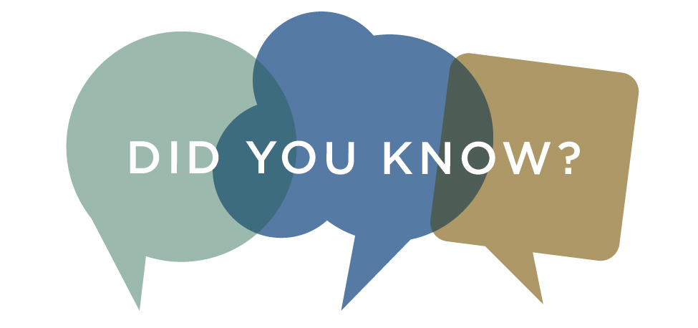
Did you know that there are Talking Book Libraries all over the world? If you move, you can continue to receive services, or if you have friends and loved ones that live in other places, they can benefit from the National Library Service for the Blind and Print Disabled. Call us for more information!

WE WANT YOUR OLD PLAYERS
If you have old Talking Book equipment that you aren’t using any more, we would like to have it back. Volunteers are able to fix up old equipment and lend it to other patrons who need it. We even take back older models such as tape decks and record players. You can box it up and put it in the mail, or put it in the Worcester Public Library book drop.

NEWSREEL

Established in 1958, NEWSREEL Magazine is a monthly audio publication for and by individuals who are blind or visually impaired. Each three-hour issue includes a variety of articles, most of which are submitted by the magazine's subscribers. The timely, informative, and entertaining magazine includes articles about news and adaptive products for people who are blind and visually impaired. Caring members also share experiences with guide dogs, travel, careers, as well as recipes, music, book reviews, and so much more. To request a three-month free trial subscription of NEWSREEL in one of several formats (including NLS-type cartridge), please email:
info@newsreelmag.org
For additional information, please visit:
http://www.newsreelmag.org
or call 1-888/723-8737 (toll free).

CONSUMER ADVISORY BOARD

The Consumer Advisory Board is the group that provides guidance and ideas to the Talking Book Library. The group discusses how to best serve the patrons of the Talking Book Library and the central MA community. We are currently looking for new members! To get involved, email us at talkbook@mywpl.org.

CONTACT US!
The Talking Book Library is located inside the Worcester Public Library at 3 Salem Square, Worcester, MA. Call us at 508-799-1730 or email us at talkbook@mywpl.org . You can also utilize the various opportunities that the WPL offers. You can also connect with us on Facebook-if you like the Worcester Public Library, we are a closed group within the page. Once we open to the public again, you will be able to visit us to use our technology, pick up and drop off books, or drop in to say hello!
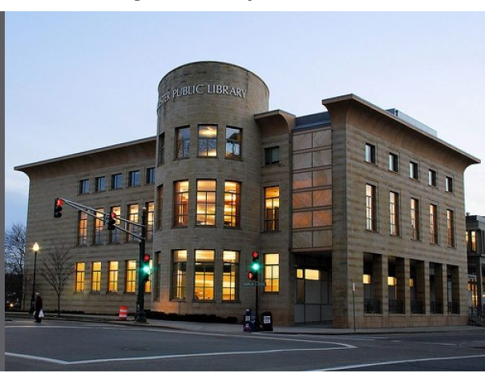

Current hours we are available by phone
Monday-Saturday 9 am - 5:30 pm

