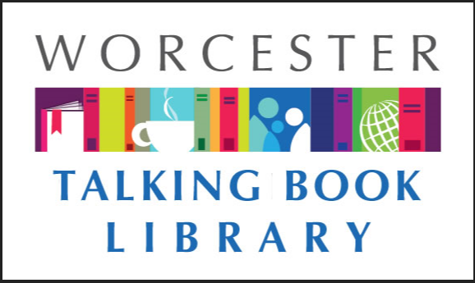 TALKING BOOKLET

Spring 2021 * Worcester Talking Book Library Newsletter

WE ARE BACK! 

After almost 14 months of being closed to the public, we are thrilled to announce that the Talking Book Library is open again! So is the Main Library branch of The Worcester Public Library, where we are located (3 Salem Square, Worcester). We are currently open for 90 minutes at a time for browsing, computer use, and picking up books. You can come visit us Monday-Saturday 9-10:30am, 11am-12:30pm, 1-2:30pm, or 3-4:30pm. Masks are required to visit and only fifty patrons are permitted in the Main Library at a time. We have missed our patrons dearly and look forward to seeing many of you soon.

If you know anyone who misses reading because they are stuck at home and may qualify for our services, send them our way. We can provide information and mail out applications to them. We know a lot of folks are lonely in their homes right now and could really use a book to keep them company.

We are currently quarantining returned items for 24 hours. If you send something back and it is still showing up as checked out on your account, this is why. TBL staff are taking necessary precautions to stop the spread of the coronavirus by practicing social distancing, wearing masks, and disinfecting surfaces in our work space and our public space. Please leave a message if you get our answering machine (508-799-1730) so we can assist you. You can also reach us by email at [talkbook@mywpl.org](mailto:talkbook@mywpl.org).

DIAL-A-STORY PROGRAM LAUNCHES

The Worcester Talking Book Library and the Worcester Public Library are bringing story time home to children, teens, and adults. The libraries have launched Dial-A-Story, a recorded service that offers stories, poems, and more by phone any time of the day or night. We will have a variety of content, from poetry to children’s stories read by WPL’s youth services staff, to recorded programming and even the TBL newsletter! It’s not just for TBL patrons or Massachusetts residents-this is for everyone!

The service is simple to use and free to the public. Listeners can reach Dial-A-Story by calling 508-552-3456; then they just need to follow the prompts to choose which content they want to hear from their favorite WPL librarians. Content in Spanish is also available. The stories are updated on a monthly basis.

CONSTRUCTION UPDATE 

We are excited to announce that the renovation has come to the Talking Book Library! Our patrons’ space has been completely renovated. We have new adjustable desks, paint, and rugs. We are looking pretty good! In addition, we will soon have a small private study space available as we open back up. This room includes a hearing loop table that can connect to the listening devices of hearing impaired persons. We will be offering some of the same amenities as before, such as assistive technology on computers, and friendly staff who will be happy to assist you.

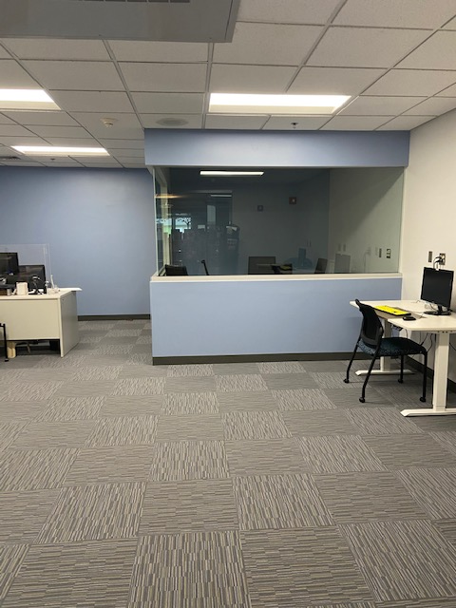

Pictured above is our new space-including computers for patron use, and a new study room.

COVID-19 INFORMATION

There can be a lot of misleading and confusing information on COVID-19 so we want our patrons to know there are reliable ways to keep informed. Some of our favorites are as follows:

Statewide information on COVID-19 can be found at [www.mass.gov/covid19](http://www.mass.gov/covid19) or by calling 211.

In the city of Worcester, resources are available at [www.worcesterma.gov/coronavirus](http://www.worcesterma.gov/coronavirus) or by calling 508-799-1019.

Some cities and towns are offering free COVID-19 tests for Massachusetts residents. For information on locations and scheduling please visit [www.mass.gov/info-details/stop-the-spread](https://www.mass.gov/info-details/stop-the-spread).

To receive up to date texts about COVID-19 on your cell phone from the Commonwealth of Massachusetts’ coronavirus response team, text 888-777.

The state’s crisis counseling assistance program can be reached at 888-215-4920.

The Massachusetts Nursing Home Family Resource line is 617-660-5399.

RECOMMENDED READS

Looking for something to read? We always have ideas! Feel free to call us at any time for some suggestions based on your interests.

**10 Blind Dates** by Ashley Elston. **DB 98168.** After an unexpected breakup, seventeen-year-old Sophie lets members of her large, eccentric extended family set her up on ten blind dates during Christmas vacation. Commercial audiobook. For senior high and older readers.

**The Bourbon King: The Life and Crimes of George Remus, Prohibition’s Evil Genius** by Bob Batchelor. **DB 098806, LT 27371** A historian recounts the exploits of a notorious criminal mastermind's Prohibition-era bootlegging operation. He discusses Remus's role as the inspiration for The Great Gatsby (DB 55714) and details the sensational murder case surrounding Remus's ultimate downfall. Unrated. Commercial audiobook.

**The Boy From The Woods** by Harlan Coben. **DB 98760. LT 28183.** Thirty years ago, Wilde was found as a boy living feral in the woods. Now, no one seems to take teen Naomi's disappearance seriously. But attorney Hester--whose grandson told her that Naomi was relentlessly bullied at school--asks Wilde to use his unique skills to find Naomi. Strong language and some violence. Bestseller.

**Dad Jokes: The Good. The Bad. The Terrible** by Jimmy Niro. **DB 96807.** A collection of jokes that a corny dad would tell his kids. The jokes are heavy on puns and silly wordplay.

**Little Gods** by Meng Jin **DB 98696, LT 29339**. On the night of June Fourth, a woman gives birth in a Beijing hospital alone. Thus begins the unraveling of Su Lan, a brilliant physicist who until this moment has successfully erased her past, fighting what she calls the mind's arrow of time. When Su Lan dies unexpectedly seventeen years later, it is her daughter Liya who inherits the silences and contradictions of her life. Liya, who grew up in America, takes her mother's ashes to China--to her, an unknown country. In a territory inhabited by the ghosts of the living and the dead, Liya's memories are joined by those of two others: Zhu Wen, the woman last to know Su Lan before she left China, and Yongzong, the father Liya has never known. In this way a portrait of Su Lan emerges: an ambitious scientist, an ambivalent mother, and a woman whose relationship to her own past shapes and ultimately unmakes Liya's own sense of displacement. A story of migrations literal and emotional, spanning time, space and class, Little Gods is a sharp yet expansive exploration of the aftermath of unfulfilled dreams, an immigrant story in negative that grapples with our tenuous connections to memory, history, and self.

**The Love Story of Missy Carmichael** by Emily Nemens. **DB 099047, LT 28137.** At seventy-nine, Missy Carmichael is estranged or separated from her family and her great love is gone. The last thing Missy expects is for two perfect strangers and one spirited dog to break through her prickly exterior and show Missy just how much love she still has to give. Unrated. Commercial audiobook

**Minor Feelings: An Asian American Reckoning** by Cathy Park Hong. **DB 98817.** A collection of essays in which the author reflects on her experiences living as an Asian American in the early twenty-first century. Traces the author's relationship with language, shame, depression, poetry, family, and female friendship. Unrated. Commercial audiobook.

**Poetry and Tales** by Edgar Allen Poe. **DB 96174.** Collection of Edgar Allan Poe's poetry and tales presented chronologically to showcase his development as a writer. Includes the five scenes from "Politian," his one attempt at drama. Edited by Patrick F. Quinn.

**Such a Fun Age** by Kiley Reid. **DB 97929.** African American babysitter Emira Tucker is accused by a security guard of having kidnapped the toddler she is caring for when she takes the girl to an upscale market. The incident is caught on film and her white employer is determined to make things right. Strong language. Commercial audiobook. Bestseller.

**Suicide Run: Three Harry Bosch Stories** by Michael Connelly. **DB 97953**. LAPD Detective Harry Bosch in three never-before-collected stories. In the title entry, the apparent suicide of a beautiful young starlet turns out to be much more sinister than it seems. Also includes "Cielo Azul" and "One Dollar Jackpot. Unrated. Commercial audiobook.

**Yellow Bird: Oil, Murder, and a Woman's Search for Justice in Indian Country b**y Sierra Crane Murdoch. **DB 98873** When Lissa Yellow Bird was released from prison in 2009, she found her home--the Fort Berthold Indian Reservation in North Dakota--transformed by the Bakken oil boom. Three years later, when Lissa learned that a young white oil worker had disappeared from his reservation worksite, she obsessively hunted for clues to his disappearance. Unrated. Commercial audiobook.



Did you know the NLS has made it easier than ever before for people with learning disabilities to qualify for talking book services? Previously, persons with reading disorders needed signatures from medical doctors. Now a greater variety of qualified professionals can sign off, including reading specialists, speech pathologists, and librarians. If you know someone with a reading disability who could benefit from our service, send them our way!

SUMMER READING IS BACK!

It’s almost summer which means it’s time for summer reading! This year’s theme is Tails and Tales and we have some great animal themed-events to go with it. Summer reading kicks off June 7th with some great virtual events and information. In addition, for every week you log your reading we will donate $1 to the Worcester Animal Rescue League to help feed pets waiting for adoption. You can also sign up to win great prizes for all ages - from toys to restaurant gift cards for adults. For more information or help signing up, call 508-799-1725 or visit [www.mywpl.beanstack.org](http://www.mywpl.beanstack.org).

SHAKESPEARE IN THE PARK

The Hanover Theatre and Conservatory for the Performing Arts is excited to offer Shakespeare’s Julius Caesar as a gift to the community of Worcester. Performances will be offered free and open to the public on the Worcester Common Saturday August, 7 through Sunday, August 22. “This production is our gift to the community, a way of saying ‘thank you’ for the extraordinary level of support we’ve been shown throughout the pandemic,” said Troy Siebels, president and CEO of The Hanover Theatre and Conservatory for the Performing Arts. “We are grateful for the opportunity to work with the city to safely bring live theater back to downtown.” Julius Caesar will run approximately 90 minutes with intermission, and feature immersive, energetic, socially distanced staging. Togas and crowd participation will be encouraged, as audiences will have the opportunity to boo and cheer along with the action. Seating will be available in the Worcester Common Oval on a first come, first served basis, while those who arrive later can bring their own lawn chairs or join the fun from a park bench. COVID-19 safety precautions will be enforced at Julius Caesar, and performances will follow state and local guidelines. To learn more about the performance, visit thehanovertheatre.org/juliuscaesar or call 877.571.SHOW (7469).

CONTACT US!

The Talking Book Library is located inside the Worcester Public Library at 3 Salem Square, Worcester, MA. Call us at 508-799-1730 or email us at [talkbook@mywpl.org](mailto:talkbook@mywpl.org). You can also like us on Facebook. We have a monthly email list as well that you can request to receive. We are open to the public for circulation and computer use, so please come by and say hello!

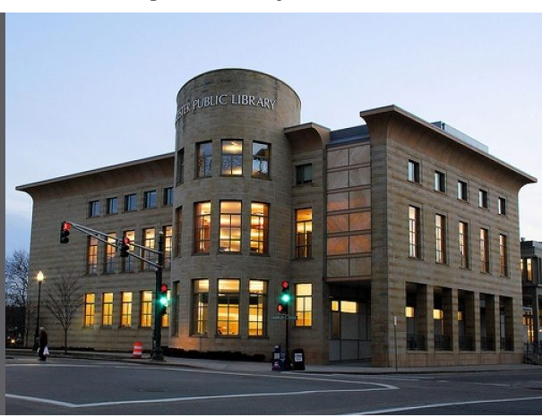

Current hours we are available by phone

Monday-Saturday 9am - 5:30pm

Current hours we are open to the public

Monday-Saturday

9-10:30am

11am-12:30pm

1-2:30pm

3-4:30pm