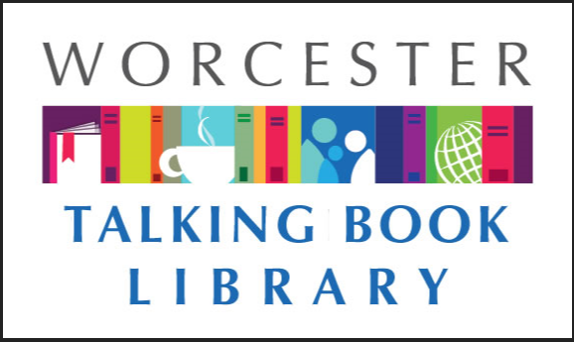
TALKING BOOKLET

Spring 2022 * Worcester Talking Book Library Newsletter
If you would prefer to listen to this newsletter in audio, call our Dial-A-Story line 508-552-3456 and select menu option #1. For other formats such as braille and email, please reach out to us at talkbook@mywpl.org or 508-799-1730, and we will make sure you get what you need as it becomes available.

PROGRAMMING RESUMES, MASKS OPTIONAL

With COVID-19 numbers in a decline, the City of Worcester has begun to loosen restrictions for public buildings including The Worcester Public Library. As of March 1st, in person programming has resumed in library branches. There is still the option of virtual programming as well for many events. Masks are now optional but encouraged. The library branches, including TBL, has masks available if you feel comfortable with one.
In addition to in-person events coming back, we are now available to attend events out in the community. We have staff on hand to come to institutions such as schools, hospitals, and retirement homes to provide information on all of the great services that we offer. If you are interested in having a staff person come to your event, call us today!
As of print, The Worcester Public Library is still hosting vaccine clinics at the Main Library. Clinics run Wednesdays from 11 a.m. to 7 p.m. and Saturdays 11 a.m. to 5 p.m. Clinics are operated by the Worcester Department of Health and Human Services and are open to all persons regardless of what town they live in. Anyone 5 and over is eligible. Johnson and Johnson, Moderna, and Pfizer vaccines are available. The clinic will also have booster shots. All vaccines are free regardless of insurance status.

NLS TO CEASE PRINTING TALKING BOOK TOPICS

Due to the rising cost of paper, The National Library Service for the Blind and Print disabled will be discontinuing the print version of Talking Book Topics. Talking Book Topics, a bimonthly large type list of new digital books, will hopefully be back by the end of the year or beginning of 2023. Staff at the Talking Book Library have been very vocal about their concern about the cessation of the print copy and hope for a swift return.

While the situation is not ideal, there are other options for talking book users looking for the latest books. Below is a list of formats where Talking Book Topics is still available
- Online for BARD at www.loc.gov/nls/tbt -this format allows for users to access BARD directly to add to their wish list or download. For more information on how you can access talking books through your smartphone or tablet, call us at 508-799-1730
- Online for non-BARD users at www.loc.gov/nls/tbt. Users can print up an order form and peruse a PDF like it is an e-book
- Audio Cartridge, which comes with an order form
- BARD provides an audio format as well that users can add to wish list or download
- Braille Book Review, which offers an abridged copy in print and also an abridged copy available for download on BARD onto a refreshable Braille reader
If you use Alexa, you can utilize Newsline to listen to a recording of Talking Book Topics. Call us for information on Newsline.

A GREAT NEW WAY TO GET TALKING BOOKS

Coming soon to TBL: duplication on demand! This new service model offers patrons the option to receive several books on one cartridge. The NLS is hoping to gradually transition all talking book users to this format.
What you need to know:
- You will still use the talking book machine; no additional equipment is needed.
- Each cartridge can contain up to 6 books! We can even send you an entire series in order on cartridges. This means fewer cartridges and less clutter!
- The process to request and return books will be exactly the same. Books will continue to be delivered by postage-free mail.
- Cartridges will be unique to you – consider it your personalized book mix!
- Most importantly: you will have access to our entire collection, including older books, with less wait time for new ones!

If you want to sign up for this new service or have questions, call us today at 508-799-1730.

LARGE TYPE BOOK CLUB IN A BAG
Introducing Large-Print Book Club in a Bag!
Are you trying to start a book club with large-print readers? The Talking Book Library is here to help! TBL patrons can now order large-print book club collections containing up to ten copies of popular titles, mailed directly to you or your institution. Getting started is simple: contact us to let us know you are interested, and we will send you a list of available titles to select. We have popular romances, thrillers, and other bestsellers. Call 508-799-1730 to sign up!

NOW OPEN SUNDAYS 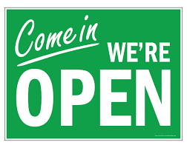

The Worcester Public Library’s Main Library is now open Sundays. That means TBL is open too! Our staff will be in our first floor public office Sundays from October to April, 12 – 4 pm. You can pick up and drop off books, use our public computers with accessibility features, or just come in to say hello! Hope to see you soon.

RECOMMENDED READS
Looking for something to read? We always have ideas! Feel free to call us at any time for some suggestions based on your interests.

The Blind Mechanic: The Amazing Story of Eric Davidson, Survivor of the 1917 Halifax Explosion. By Marilyn Davidson Elliott DB104816.
Written by his daughter, this is the life story of Eric Davidson, a boy who lost both eyes in the 1917 Halifax Explosion that also injured his mother. He overcame many challenges, later becoming a mechanic and well-known citizen of Halifax. 2018.

Charlie Chan Carries On. By Earl Derr Biggers. DB101581
Scotland Yard Inspector Duff is called in to investigate when a deaf old man, on a tour from America with his daughter and granddaughter, is murdered. Duff meets the victim's tour group when they arrive in Hawaii--and gets help from his old friend Charlie Chan, who ends up taking over the investigation. Unrated. Commercial audiobook. 1930.
The Doctors Blackwell: How Two Pioneering Sisters Brought Medicine to Women-and Women to Medicine. By Janice P. Numura. DB104506, LT029844.
Biography of Doctor Elizabeth Blackwell, the first licensed female physician in the United States, and her sister, Doctor Emily Blackwell. Discusses their early years, their founding of the New York Infirmary for Indigent Women and Children, and the challenges they faced in their chosen profession. Unrated. Commercial audiobook. 2021.
Everything Sad is Untrue (a true story). By Daniel Nayeri. DB101953, BR023597.
At the front of a skeptical classroom in Oklahoma, young Khosrou tries to tell his story. Khosrou's stories span centuries, from the moment his family fled Iran in the middle of the night to tales set in the jasmine-scented city of Isfahan. Some violence. Printz Award. For senior high and older readers. 2020.

Everyone in This Room Will Someday Be Dead. By Emily Austin. DB104333, LT039058
Gilda, a twenty-something animal-loving lesbian atheist, cannot stop ruminating about death. Desperate for relief from her panicky mind, she responds to a flyer for free therapy at a local Catholic church, and finds herself being greeted by Father Jeff, who assumes she's there for a job interview. Unrated. Commercial audiobook. 2021.

The Four Winds. By Kristin Hannah. DB102287, DB104103(Spanish), LT029514.
Texas, 1921. Elsa Wolcott has few prospects before her as she's considered too old to marry. Then she meets Rafe Martinelli. Thirteen years later, everything on the Martinelli farm is dying--including their marriage. Elsa must decide to fight for the land of her heart or head to California. Unrated. Commercial audiobook. Bestseller. 2021.

Frida in America: The Creative Awakening of a Great Artist. By Celia Stahr. DB101615
Art historian examines the work and life of Mexican artist Frida Kahlo while she lived in America with new husband and fellow artist Diego Rivera. Discusses the influence of living in the place Kahlo called "Gringolandia" on her sense of Mexican identity and subsequent work. 2020.
The Greatest Beer Run Ever: A Memoir of Friendship, Loyalty, and War. By John “Chick” Donahue and J.T. Molloy. DB101979
An account of John "Chick" Donohue's scheme to sneak into Vietnam during the Vietnam War to deliver supportive messages and beers to his soldier buddies serving there. Unrated. Commercial audiobook. Bestseller. 2017.

Hush-Hush. By Stuart Woods. DB101699, LT029340.
Stone Barrington is settling in for some downtime in New York City when an anonymous enemy makes himself known. This nameless foe's threats hit close to home, and before Stone can retaliate, the fearsome messages turn into very real consequences. With the help of old friends--and a lovely new tech-savvy acquaintance--Stone investigates. Unrated. Commercial audiobook. 2020.
Keep Sharp: How to Build a Better Brain at Any Age. By Sanjay Gupta. DB101866.
Neurosurgeon debunks myths about aging and cognitive decline, explores whether there's a "best" diet or exercise regimen for the brain, and discusses whether it's healthier to play video games that test memory and processing speed, or to engage in more social interaction. Addresses brain disease, particularly Alzheimer's. Includes a twelve-week program of brain-strengthening strategies. Unrated. Commercial audiobook. Bestseller. 2021.

The Story of Sigurd the Volsung and the Fall of the Niblings. By William Morris DB104031
An epic poem drawn from Norse mythology that tells the tragic story of Norse hero Sigmund, his son Sigurd, and Sigurd's wife Gudrun. 1876.
Did you know about the low vision support group that meets in the City of Worcester? The group provides a safe and confidential place for members to gather and discuss things of interest to the low vision community. Meetings are free and happen the third Friday of every month and offer support and resources for folks of all ages. For more information, contact Marion at ganglion10@verzon.net or call TBL for assistance reaching out.

TBL ACCESSIBILITY TRAINING
We are pleased to offer the following accessibility training workshops at the Worcester Public Library’s Main Branch. All classes are from 10 -11 a.m. and will be held in the First Floor Computer Lab, located in the Newspapers and Magazines section. Special thanks to Donna and Nona, our trainers!
April 21 How to use the on screen keyboard and dictation
May 19 How to edit contacts

WPL PROGRAMS
Worcester Public Library is providing programs in both in-person and virtual formats. Here is a list of a few upcoming events that we wanted to share.
An R means registration is required. Call 508-799-1725 to make sure you have a space.

An Afternoon with the Worcester Poets Laureate (R)
Friday April 15, 4 - 5 p.m. Zoom
Join the City of Worcester Poets Laureate Juan Matos and Adael Mejia for an afternoon of poetry in celebration of National Poetry Month. This program is hosted in partnership between WPL and the City of Worcester’s cultural Development Division. Ages 16+ TBL is also featuring works from our poets on Dial-A-Story in April! Call 508-552-3456 to listen.

DIY Investing: A Beginner’s Class (R)
Thursdays: April 14, May 12, 2:30 – 4 p.m., First Floor Computer Lab
Lean how to invest, and the importance of asset allocation to build a balanced portfolio.

Finding your Irish Ancestors at WPL (R)
Saturday, May 21 4 - 5 p.m. Zoom
Trace the lives of your Irish ancestors.

Get Organized this Spring! Workshop with Jenna Elliott
Saturday, April 2, 2:30 - 3:30 p.m. Zoom
This fun, interactive workshop will get you focused on your organizing goals.

True Crime Book Club (R)
Wednesdays: April 13, May 11, 7 – 8 p.m. Zoom

CONTACT US!
The Talking Book Library is located inside the Worcester Public Library at 3 Salem Square, Worcester, MA. Call us at 508-799-1730 or email us at talkbook@mywpl.org. You can also like us on Facebook. We have a monthly email list as well that you can request to receive. We are open to the public for circulation and computer use, so please come by and say hello!
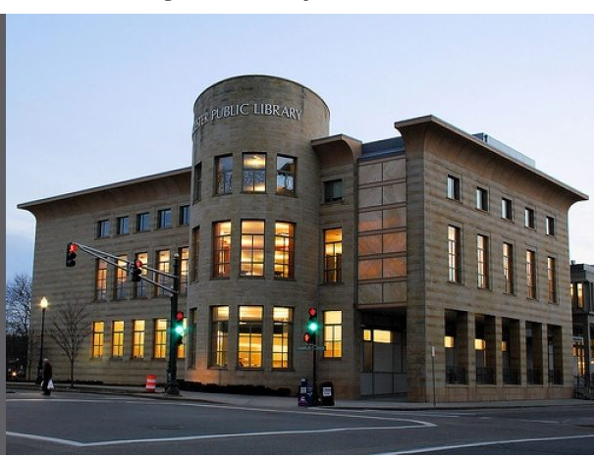

Monday-Saturday
9 – 5:30 p.m.

Sunday
12 – 4 p.m.

