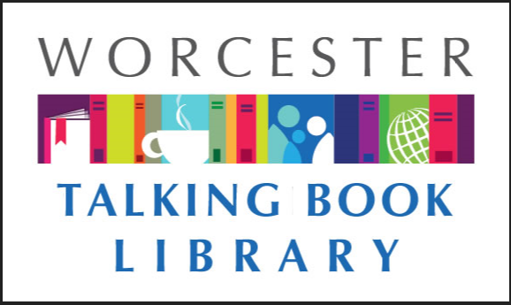
TALKING BOOKLET

Summer 2019 * Worcester Talking Book Library Newsletter

THANK YOU FOR THE FEEDBACK!

We were absolutely thrilled with all of the kind words that our patrons shared with us in regards to bringing the newsletter back. If there is anything in particular you would like to see featured here, please let us know - this is your newsletter and we want to provide you with the information you want.
If you would prefer to get this newsletter in audio, electronic, or Braille formats, please reach out to us at talkbook@mywpl.org or 508-799-1730, and we will make sure you get what you need as it becomes available.

WPL TO UNDERGO A MAJOR RENOVATION 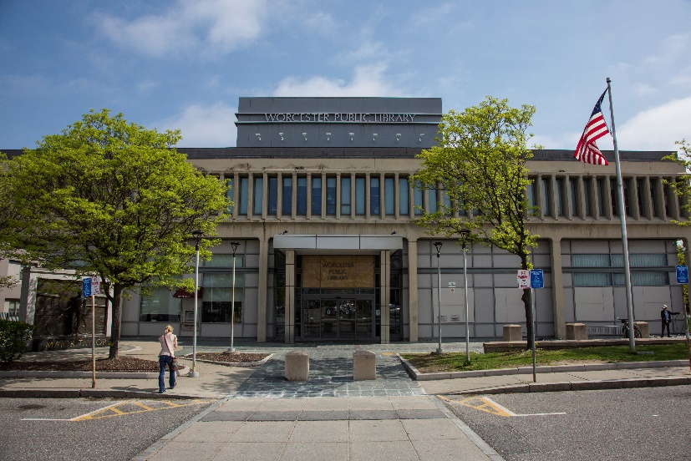

The Worcester Public Library is planning a major renovation to the main library-including the Talking Books Area! Over the course of a year, a lot of changes are coming. “All of these projects are giving us the opportunity to offer lots of new programs and services to our patrons,” says Geoffrey Dickinson, the Head Librarian of WPL.
Traditionally, patrons have entered through the back of the library (pictured above). The library has not had a door on the front of the building, but all of that is about to change; we are adding an entrance on the front, and closing off the Salem Street entrance on the side of the building. The children’s room will be moving from the first floor to the third, and the periodicals section will be moving down to the first.
The Talking Book area is planning a facelift as well. We are getting new carpeting and furniture, and also a small room for meetings and educational use. There might be a brief period of time where our public space is closed due to the renovations, but we will do our best to keep our patrons informed.
Groundbreaking is scheduled for June 12th, with the actual construction process beginning soon after. We will use this newsletter to keep our patrons posted on the progress. If you have any questions, or want to come visit and see how things are going, let us know!

ASSISTIVE TECHNOLOGY TRAINING IS BACK!
If you have attended our assistive technology workshops in the past, you know how important and useful they were. While we cannot have large classes in the library until after the renovation due to space constraints, we are working with members of the community to offer training once again.
Nona Haroyan, the chair of our advisory board, Donna Ellis, and Mary Haroyan are offering one-on-one training sessions with patrons. Patrons can choose to learn a variety of technologies that might be useful to them, such as how to make their smartphones more accessible, and how to use their tablets to access the internet with low vision technologies. You can choose what you wish to learn! For more information, or to set up an appointment, please email Nona at nharoyan@charter.net.

LIKE US ON FACEBOOK

Want to see what’s new at the Talking Book Library as soon as the news breaks? Follow us on Facebook. If you Like the Worcester Public Library page and then ask to join the Talking Book Library group, you will have access to information. Here, we offer information about hours and programs and anything we feel that might be useful or interesting for our patrons to know. Once you join us, let us know if there’s anything in particular you’d like to see in the space. We are here to make sure our patrons get the right information.

RECOMMENDED READS
An Irish Country Cottage by Patrick Taylor. DB092669, LT024941. 1968. Soon after the Christmas holidays, a fire engulfs the home of Donal Donnelly, leaving his family with only the clothes they were wearing. The villagers of Ballybucklebo rally around them to give aid. Meanwhile, Doctor Barry Laverty and his wife contemplate medical intervention for conception. Unrated. Commercial audiobook. 2018.

The Big Fella: Babe Ruth and the World He Created by Jane Leavy. DB093005, LT024885. Biography of George Herman "Babe" Ruth (1895-1948), the New York Yankees slugger who was the model for modern celebrity. Details his life and career, including his partnership with manager Christy Walsh, and the media circus that followed his historic sixtieth home run in 1927. Unrated. Commercial audiobook. 2018.

Complete Novels: The Heart is a Lonely Hunter, Reflections in a Golden Eye, The Ballad of the Sad Café, The Member of the Wedding, Clock Without Hands by Carson McCullers. DB091754. Five novels published between 1940 and 1960. In The Heart Is a Lonely Hunter, John Singer, who is deaf and mute, becomes a confidant to several town residents. In The Member of the Wedding, a young girl invites herself to the honeymoon. Some strong language and some descriptions of sex. 1960.

Gmorning, Gnight! Little Pep Talks for Me and You by Lin-Manuel Miranda. DB092671. The creator and star of the stage musical Hamilton has shared countless words of encouragement through his Twitter account for years. This collection of some of his favorite daily greetings and affirmations is meant to inspire and comfort readers. Unrated. Commercial audiobook. 2018.

Heads You Win by Jeffrey Archer. DB092903, LT024911. Leningrad, 1968. Alexander Karpenko's life is upended when the KGB murders his father. A coin flip will decide Alex's new home: the United States or Great Britain. He and his mother flee, and thirty years pass before he chooses to return. Unrated. Commercial audiobook. 2018.

I Am Not Your Perfect Mexican Daughter by Erika Sanchez. DB089358. After her older sister, Olga, dies suddenly, Julia knows she cannot live up to her sister's standards in the eyes of her traditional family. But she soon discovers that Olga may not have been as perfect as everyone thought. Commercial audiobook. 2017.

The Library Book by Susan Orlean. DB092869, LT024838, BRC01820. The author re-opens the unsolved mystery of the most catastrophic library fire in US history. On April 29, 1986, fire broke out at the Los Angeles Public Library and destroyed or damaged more than a million books. Examines the evolution of public libraries while celebrating their value in society. Unrated. Commercial audiobook. 2018.

My Love Story by Tina Turner. DB092875, LT025845. Legendary singer aims to set the record straight about her career and complicated personal life. Covers her early life in Tennessee, her rise to fame with husband Ike Turner, her success as a solo artist, and the sometimes dark hours in between. Unrated. Commercial audiobook. 2018.

The Next Person You Meet In Heaven by Mitch Albom. DB092876, LT024795, BR022478. Years after an accident left her scarred and traumatized, Annie from The Five People You Meet in Heaven (DB 57004) is celebrating her wedding to childhood sweetheart Paulo. But another accident leads Annie to meet the man who saved her life all those years ago. Unrated. Commercial audiobook. Bestseller. 2018.

The Ravenmaster: My Life with the Ravens at the Tower of London by Christopher Skaife. DB092571, LT025183. The author describes the history and work of his role as Ravenmaster at the Tower of London. Discusses the ravens' needs, behavior, social structure, and interactions with humans. Also examines folklore, history, and superstitions surrounding the birds and the Tower. Unrated. Commercial audiobook. 2018.

Robert B Parker’s The Hangman’s Sonnet BY Reed Farrel Coleman. DB089021, LT022634. Paradise Police Chief Jesse Stone learns that a gala seventy-fifth birthday party is to be held for folk singer Terry Jester, who has spent the last forty years in seclusion after the mysterious disappearance of the master recording tape of his magnum opus, The Hangman's Sonnet. Unrated. Commercial audiobook. 2017.

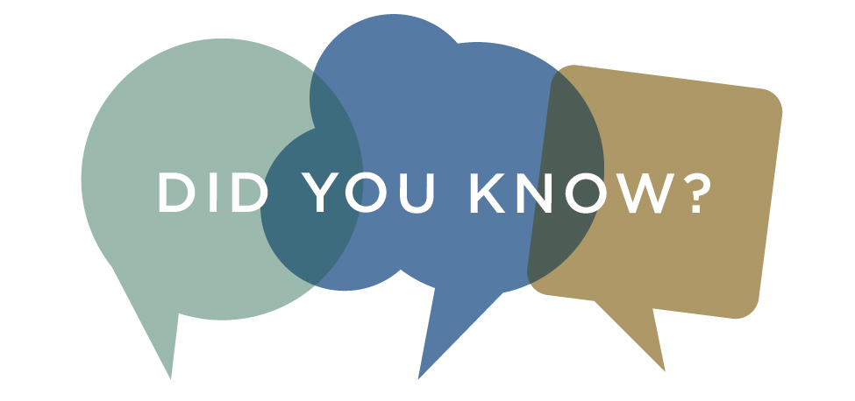
Did you know that we have more than just audiobooks? WTBL also loans out large type adult books, as well as descriptive DVDs. If you are interested in learning more about either of these programs, get in touch with us today!

SUMMER READING PROGRAMS
Both the Worcester Public Library and the Perkins Library are offering summer reading programs for all ages. The theme this year is “A Universe of Stories.”
The WPL web site uses an online tracking system where patrons can keep track of how many minutes they have read (youth) or how many books they have read (adults). The more you read, the more you have a chance to win some fantastic prizes.
Perkins is also doing “A Universe of Stories” for the theme this year. They will be mailing out information to kids and teens across the state who are enrolled in Talking Book Library services. There will be opportunities to win prizes based on the amount of reading done.
If you are interested in participating in either of these programs, let us know and we can connect you to the right resources.

GREAT EVENTS HAPPENING AT WPL!
There are always lots of exciting and interesting events happening at the Worcester Public Library. Here are a few upcoming ones:

Pop Up Book Sales
Tuesdays 2-5 pm and Saturdays 10 am - 1 pm
Come stop by the Lobby of the Main Library to visit the Friends of the Worcester Public Library's Pop Up Book Sales. The Friends will be hosting these sales while the book store is closed for renovations, and they will have new items at each sale, so come on by to support the Friends and see what exciting books we have for you!

English Conversation Circle
Tuesdays 5:30 – 7 pm
Practice speaking English in a relaxed, comfortable place, and meet new friends as we learn by talking together.

Worcester Writer’s Group
Tuesday, July 9, 5:30 - 7 pm

Are words your passion? Worcester Writer’s Group may be of interest to you. This group meets regularly. For more information, contact wplref@mywpl.org.

Meteorites: Thunderstones from Space
Saturday, July 13, 1 – 2 pm
Aldrich Astronomical Society presents a history of our understanding of meteorites, including great displays of some of the rocks recovered from the largest falls! All ages welcome!

CONSUMER ADVISORY BOARD

The Consumer Advisory Board is the group that provides guidance and ideas to the Talking Book Library. We are currently looking for new members. To get involved, email us at talkbook@mywpl.org.

CONTACT US!

The Talking Book Library is located inside the Worcester Public Library at 3 Salem Square, Worcester, MA. Call us at 508-799-1730 or 1-800-762-0085, or email us at talkbook@mywpl.org .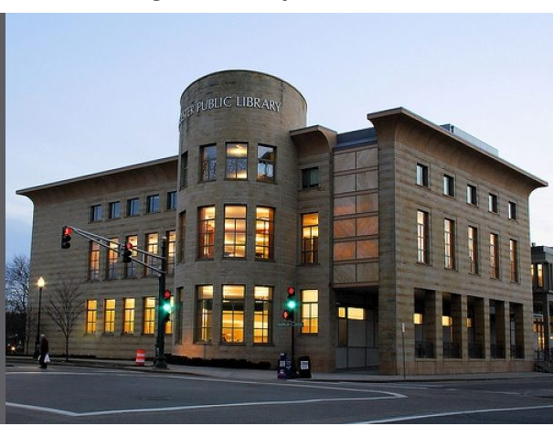

Current hours
Monday-Saturday 9 am - 5:30 pm

