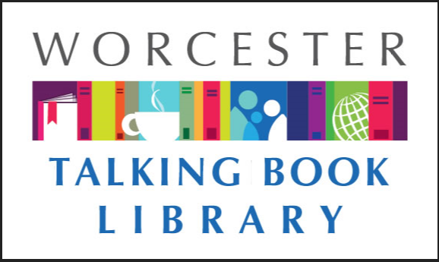
TALKING BOOKLET

Summer 2022 * Worcester Talking Book Library Newsletter
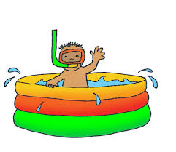
If you prefer to listen to this newsletter in audio, call our Dial-A-Story line 508-552-3456 and select menu option #1. For other formats such as braille and email, please reach out to us at talkbook@mywpl.org or 508-799-1730, and we will make sure you get what you need as it becomes available.
BOOKS ON DEMAND-YOUR BOOKS, YOUR WAY
Do you have too many talking books cluttering your space? Do you wish that you could get a copy of something specific only to be told that we do not have it? Well, look no further! The Talking Book Library is now offering Books on Demand. This new service model offers patrons the option to receive several books on one cartridge. You can still do one book per cartridge as well-we love options! You can use the same machine you’ve been using, and we can help by providing instructions on how to navigate the cartridges with multiple books. Some of our patrons are already using this module and the feedback has been positive. A lot of folks use it to listen to series in chronological order. Every talking book on demand is unique. Here at the library, we can take your requests and put them all on one cartridge. Once you send it back, we delete the contents and put different titles on them. While we are giving patrons the opportunity to try this out, eventually this will be the only method to receive books. We know this might sound intimidating, but we are here to help.
If you want to sign up for this new service now or have questions, call us today at 508-799-1730, or email talkbook@mywpl.org.

NLS TO CEASE PRINTING TALKING BOOK TOPICS
Due to the rising cost of paper, The National Library Service for the Blind and Print disabled will be discontinuing the print version of Talking Book Topics. Staff here at the Talking Book Library have been very vocal about their concern regarding the cessation of this service.
While the situation is not ideal, there are other options for talking book users looking for the latest books. Below is a list of formats where Talking Book Topics is still available:
- Online for BARD at www.loc.gov/nls/tbt -this format allows for users to access BARD directly to add to their wish list or download. For more information on how you can access talking books through your smartphone or tablet, call us at 508-799-1730 or email us at talkbook@mywpl.org .
- Online for non-BARD users at www.loc.gov/nls/tbt. Users can print up an order form and peruse a PDF like it is an e-book
- Audio Cartridge, which comes with an order form
- BARD provides an audio format as well that users can add to wish list or download
- Braille Book Review, which offers an abridged copy in print and also an abridged copy available for download on BARD onto a refreshable Braille reader
If you use Alexa, you can utilize Newsline to listen to a recording of Talking Book Topics. Call us for information on Newsline.

WALKFIT-GET MOVING, MAKE FRIENDS!
The following article was written by our friend Liz Myska, a TBL patron and advocate for the low vision community.
My name is Liz Myska. I am a VIP (visually impaired person). I started losing my sight in 2008 as an adult. As my sight dwindled (I have a progressive retinal disease), I wondered about others experiencing sight loss. I wondered about those who were born blind, those who were born legally blind, but also those whose sight loss was a result of an accident or a chronic condition like diabetes. Over the 14 years I have been legally blind, I have formed opinions about my own sight loss and its ramifications on my life and livelihood. I wondered what it was it like for others. What feelings were individuals experiencing? What psychological and social impacts had occurred as a result of vision loss? Were individuals afraid to stick a toe in societal waters, were individuals sinking, dog paddling, crawling or stroking strongly and confidently through the sea and was this happening in all realms on a rare, occasional, or frequent basis?
I yearned to meet others similarly situated but it was frustratingly difficult to do so. I could not see others so unless a person disclosed or acknowledged sight loss, I had no idea if he/she/ they was a VIP comrade. I did not want to affiliate with a group; I did want to befriend other VIPs and “compare notes”.
I co-created Walkfit, what I call my walking initiative in 2015, with an optometry student from the Worcester campus of MCPHS (Mass College of Pharmacy and Health Sciences). Since 2015, we have welcomed volunteers from other academic institutions, including UMass Medical School and local colleges and high schools.
Walkfit involves movement. Sighted volunteers of all ages and backgrounds are coupled with VIPS (visually impaired persons) of all ages and backgrounds, all of whom are contending with less sight than normal. During Walkfit, participants “go for a walk” together. These walks are conducive to conversation. The pairs ambulate, talking while walking, learning from, learning about and learning with one another each step of the way. Walkfit is good for one’s physical wellbeing as well as one’s mental wellbeing. People connect. Typically, the environment where the walks occur varies from week to week. The walks take place primarily on a Saturday, usually in the morning and usually in the City of Worcester proper. There is usually an out of door component to each walk and therefore walks are weather dependent. I announce the time and the location of the walk the Wednesday before the Saturday. I notify participants by email, text, or occasionally I phone if there is no other way to communicate. If you are interested in walking with us, reach out by emailing eyeaudioradio@gmail.com. Be sure to identify yourself and your interest in Walkfit in the text or the email. Don’t have text or email capability? Contact the Talking Book Library, staff will know how to put us in touch.
Not a VIP, but want to get in sync with Walkfit? We train guides year round. Reach out-we want to meet you and have you belong to Walkfit too.

LOW VISION MONEY COUNTER AVAILABLE
Through a government program, the Talking Book Library is now able to offer iBill money counters to patrons free of cost. This device can be used to quickly identify the denomination of bills by placing them in a slot. It’s small enough to carry in a pocket or handbag and features a long battery life (a AAA battery is included and easy to replace). All it takes is the click of a button and it can quickly identify any paper U.S . Currency. Contact us today if you are interested in receiving one.

RECOMMENDED READS
Looking for something to read? We always have ideas! Feel free to call us at any time for some suggestions based on your interests.

All About Me! My Remarkable Life in Show Business. By Mel Brooks. DB 105810, LT 30905. Memoir from a multiple award-winning director, actor, and comedian. He describes his childhood in Brooklyn and his first big break as a writer for Sid Caesar's Your Show of Shows, before going on to write, direct, and star in hit films such as The Producers. Unrated. 2021.
Black Bird in the Sky: The Story and Legacy of the 1921 Tulsa Race Massacre. By Brandy Colbert. DB 105765, BR 23989. An award-winning author recounts one of the most devastating acts of racial violence in U.S. history. In 1921, an armed white mob razed the predominantly Black Greenwood District. Colbert examines how this horrific event came to pass and why this history is still unknown to many of us. Violence and some strong language. For senior high and older readers. 2021.
Chemistry for Breakfast: The Amazing Science of Everyday Life. By Mai Thi Nguyen-Kim. DB 105822. Chemist presents an introduction to chemistry found in our everyday lives using the construct of what happens in the course of a day. Topics include our bodies' hormones, the ingredients in personal care items, and what makes food delicious. Translated from the original 2019 German edition. Unrated. 2021.
Clive Cussler’s the Devil’s Sea: A Dirk Pitt Novel. By Dirk Cussler. DB 105769, LT 30633. In 1959, a treasured Buddhist artifact was lost to history. Sixty years later, NUMA Director Dirk Pitt discovers a forgotten plane crash in the Philippine Sea. While exploring the crash, Dirk and Al Giordino are ordered to recover a missile that others are after as well. Unrated. 2021.
Dangerous Women. By Hope Adams. DB 106036. Englishwomen file aboard the Rajah, embarking on a three-month voyage to Australia. They're daughters, sisters, mothers--and convicts, transported for petty crimes. Except one of them has a deadly secret, and will do anything to flee justice. Unrated. Commercial audiobook. 2021.
The Hidden World of the Fox. By Adele Brand. DB 102144. Ecologist who has studied foxes for over twenty years across four continents presents a natural history of the fox and argues that it is one of the species best adapted to modern living. Uses scientific research, cultural anthropology, and her own fieldwork to make her case. Unrated. Commercial audiobook. 2019.
Murder Most Fowl: A Wildwood Witch Mystery. By Elle Adams. DB 104975. Not everyone is happy Robin Wildwood has gained the title of Head Witch. She's determined to make the best of her unexpected position with her squirrel familiar Tansy at her side. But when she judges a local familiar contest and a contender drops dead, Robin must find the killer. 2021.
The Orphan’s Guilt. By Archer Mayor. DB 105455, LT 29469. When John Rust is arrested for drunk driving, an investigation into his past for mitigating circumstances leads to a homicide investigation. Joe Gunther and his team are called in and they uncover a story of avarice, betrayal and vengeance surrounding John Rust and his brother as children. Unrated. 2020.
The Sentence. By Louise Erdrich. DB 105798 LT 30589, BR 24020. After her release from prison, Tookie takes a job at a Minneapolis bookstore. The store is haunted by the ghost of Flora, a former customer who had a habit of claiming to have Native American heritage. Tookie must solve the mystery of this haunting while Minneapolis endures a year of upheaval. Strong language and some descriptions of sex. 2021.
Taste: My Life through Food. By Stanley Tucci. DB 105460, LT 30494, BR 23963. Actor known for his supporting roles, including Paul Child in Julie & Julia, reflects on his relationship with food throughout his life. Discusses growing up in an Italian American family, food served on film sets, and dealing with a form of oral cancer. Strong language. Commercial audiobook. Bestseller. 2021.
What Strange Paradise. By Omar El Akkad. DB 105739, LT 30241. Bodies wash up on the shores of a small island after another dilapidated ship sinks under the weight of its passengers. Syrians, Ethiopians, Egyptians, Lebanese, Palestinians--all desperate to escape untenable lives in their homelands. But miraculously, nine-year-old Amir has survived the passage and is rescued by local teen Vänna. Unrated. 2021.
Where the Deer and the Antelope Play: The Pastoral Observations of One Ignorant American Who Loves to Walk Outside. By Nick Offerman. DB 105515 The actor and author of Paddle Your Own Canoe (DB 78148) shares observations from three journeys he took across America, including a hiking trip in Glacier National Park. The experiences inspired his mission statement about comprehending, protecting, and truly experiencing the outdoors. Unrated. 2021.

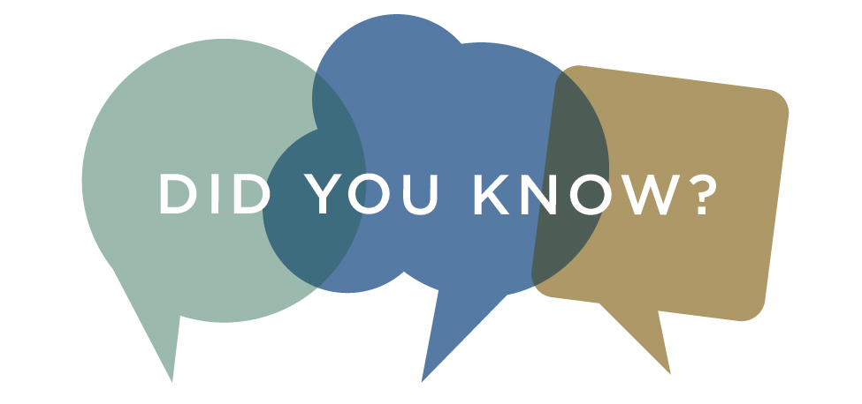
Did you know that the Talking Book Library offers Wonderbooks? These are books with built in audio for children to listen to their favorite stories. We have a range from picture to chapter books. The audio is interactive and fun! Not only do we encourage our younger readers to check one out, but any adults looking to read with the little ones in their life will enjoy these as well. Contact us today to try one out!

TBL ACCESSIBILITY TRAINING
We are pleased to be able to offer our patrons the chance to learn how to use their smartphones and tablets more efficiently. Nona and Donna not only offer one-on-one training, but on the third Thursday of each month they have a drop in session at 10 a.m. in the Main Branch of the Worcester Public Library. Come in to learn about voice over commands, setting up email, and even using BARD to listen to talking books over your phone. For information about one on one time with the trainers, contact us today.

WPL PROGRAMS
Worcester Public Library is providing programs in both in-person and virtual formats. Here is a list of a few upcoming events that we wanted to share.
An R means registration is required. Call 508-799-1725 to make sure you have a space.
Worcester Public Library Block Party! Saturday, August 13, 11:30 a.m.-2:30 p.m. Join WPL for OUR SECOND ANNUAL Community Block Party for all ages! The event will include free FUN activities and entertainment, plus food trucks and vendors. We hope to see you there!
Free performances and programs include DJ Chuck Chillin, Wicked Good Henna, Face Painting by Face Escape, East Coast Entertainment Photo Booth, Magic Fred's Magic Show, Curious Creatures Reptile Exhibit, and inflatable slide/basketball. There will also be a Friends of the Library book sale!
We'll also have over 60 vendors and food trucks, including crafts, non-profits, kid’s programs, and so much more! Parking in the McGrath lot is free during the block party!

The Beauty in Breaking: Author Talk with Michelle Harper. August 22 at 9 p.m. Virtual. This author talk with Michele Harper will cover many of the lessons she’s learned on her inspiring personal journey and the success of her New York Times bestselling memoir, The Beauty in Breaking (DB 99692).

Author Talk with Simon Winchester. September 20 at 2 p.m. Virtual. Join us for a conversation with prolific British-American writer, journalist, and consummate adventurer Simon Winchester. This author talk will cover many aspects of his work across myriad fields of history, technology, and geology as well as the author's personal expeditions, including his path to becoming the acclaimed best-selling author he is today. A master storyteller, Winchester’s narrative is like a journey through time. His keen intellect and ability to precisely and expertly weave everyday life into historical examination leaves his readers feeling awestruck at the world surrounding them.
Winchester is a New York Times Bestselling author with an omnibus of more than 30 titles, including The Professor and the Madman (DB 46906, BR 11743), Pacific (DB 84250, LT 19481), The Perfectionists (DB 92192, LT 23965), and most recently, Land: How the Hunger for Ownership Shaped the Modern World (DB 103568, LT 29726).

CONTACT US!
The Talking Book Library is located inside the Worcester Public Library at 3 Salem Square, Worcester, MA. Call us at 508-799-1730 or email us at talkbook@mywpl.org. You can also like us on Facebook. We have a monthly email list as well that you can request to receive. We are open to the public for circulation and computer use, so please come by and say hello!
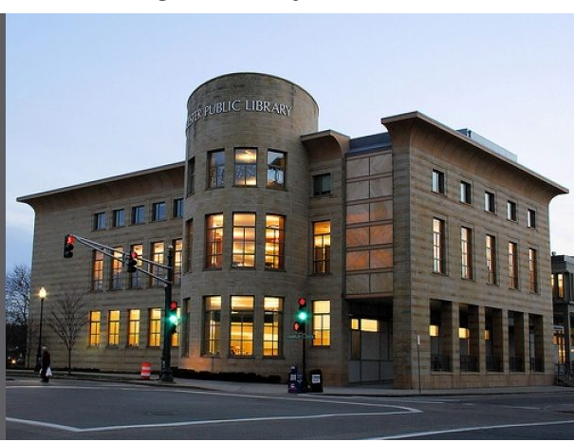

Monday-Saturday
9 – 5:30 p.m.
Sunday
12 – 4 p.m.

