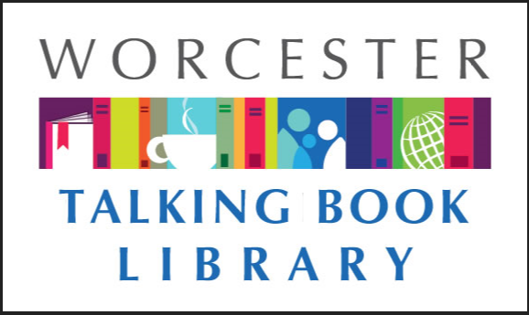 TALKING BOOKLET

Winter 2021 * Worcester Talking Book Library Newsletter

HAPPY NEW YEAR! 

The Talking Book Library would like to wish our patrons and their loved ones a happy and healthy 2021. We certainly had an interesting 2020: COVID means that the Worcester Public Library, where we are located, has been mostly shut to the public since March. We never thought we’d be shut for ten months! However, despite the many challenges this year, we’ve been able to continue to circulate books to our patrons and spread the word to new patrons about the work we do. If you know anyone who is missing reading because they are stuck at home and qualifies for our services, send them our way. We can provide information and mail out applications to them. We know a lot of folks are lonely in their homes right now and could really use a book to keep them company.

We are currently quarantining returned items for 72 hours. If you send something back and it is still showing up as checked out on your account, that’s why. TBL staff are taking necessary precautions to stop the spread of the coronavirus by practicing social distancing, wearing masks, and disinfecting surfaces in our work space. We are also staggering staffing and as a result might not be able to answer the phone as quickly as we’d like. Please do leave us a message if you get our answering machine (508-799-1730) so we can assist you. You can also reach us by email at [talkbook@mywpl.org](mailto:talkbook@mywpl.org)

These days, the post is running a bit slow due to the high volume of packages as well as COVID outages within the USPS staff. We encourage you to consider ordering a few more books than usual so you will have something to read at all times.

DOWNLOAD AND LISTEN TO BOOKS AT HOME

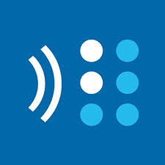

If you are interested in being able to enjoy a talking book whenever you’d like, BARD can help! BARD Mobile, which is a program offered to all WTBL patrons through the National Library Service for the Blind and Print Disabled, allows patrons to enjoy the freedom of listening to a book whenever they want. If you have a tablet or a smartphone, you can stream books directly onto your device.

Prefer to use your talking book player? As long as you have a computer at home and internet, you can still enjoy BARD services. We can send you a blank cartridge, a cable, and directions to help get you set up to download your own books all at no cost to you. We want our patrons to be able to enjoy reading in the way that is best for them.

CONSTRUCTION UPDATE 

The renovation is continuing along in the main branch of the Worcester Public Library and we’ve seen a lot of progress since our last newsletter. The periodicals section which was formerly located on the third floor has moved down to the first. We can’t wait to reopen and show off this wonderful space to the public. The children’s room will move to a new space on the third floor. As of right now, things are stripped down to the studs there, but we hope to have some news about it in our next addition of the newsletter. Stay tuned!

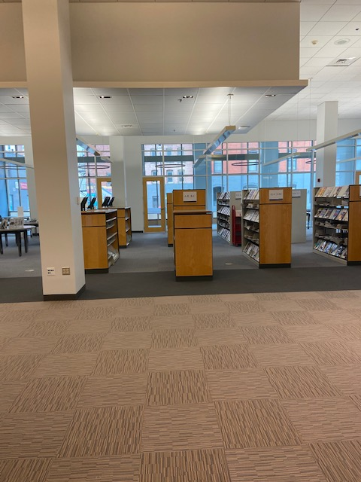

Pictured above is a small part of our new periodicals area. There are lots of magazines on display on shelves, as well as large bright windows and quiet spaces.

COVID INFORMATION

There can be a lot of misleading and confusing information on COVID-19 so we want our patrons to know there are reliable ways to keep informed. Some of our favorites are as follows:

Statewide information on COVID-19 can be found at [www.mass.gov/covid19](http://www.mass.gov/covid19) or by calling 211

In the city of Worcester, resources are available at [www.worcesterma.gov/coronavirus](http://www.worcesterma.gov/coronavirus) or by calling 508-799-1019

Some cities and towns are offering free COVID tests for Massachusetts residents. For information on locations and scheduling please visit <https://www.mass.gov/info-details/stop-the-spread>

To receive up to date texts about COVID on your cell phone from the Commonwealth of Massachusetts’ coronavirus response team, text 888-777

The state’s crisis counseling assistance program can be reached at 888-215-4920

The Massachusetts Nursing Home Family Resource line is 617-660-5399

RECOMMENDED READS

Looking for something to read? We always have ideas! Feel free to call us at any time for some suggestions based on your interests.

**Beijing payback** By Daniel Nieh. **DB 96605** Victor Li is devastated by his father's murder, and shocked by a confessional letter he finds among his father's things. In it, his father admits that he was never just a restaurateur--he was part of a vast international crime syndicate formed during China's leanest communist years. Unrated. Commercial audiobook. 2019.

**Bringing down the duke** By Evie Dunmore **DB 96458, LT 27996** England, 1879. Annabelle Archer, the brilliant but destitute daughter of a country vicar, has earned a place among the first cohort of female students at Oxford. In return for her scholarship, she must support the rising women's suffrage movement. Her charge: recruit men of influence to champion their cause. Her target: Sebastian Devereux, the calculating Duke of Montgomery who steers Britain's politics at the Queen's command. Her challenge: not to give in to the attraction she can't deny for the man who opposes everything she stands for. Locked in a battle with rising passion and a will matching her own, Annabelle will learn just what it takes to topple a duke.

**Caste : the origins of our discontents** By Isabel Wilkerson **DB 100088, LT 29020** Explores how America today and throughout its history has been shaped by a hidden caste system, a rigid hierarchy of human rankings. Beyond race, class, or other factors, there is a powerful caste system that influences people's lives and behavior and the nation's fate. Linking the caste systems of America, India, and Nazi Germany, Wilkerson explores eight pillars that underlie caste systems across civilizations, including divine will, bloodlines, stigma, and more.

**The contender: the story of Marlon Brando** By William J Mann **DB 97254** Biography of the Academy Award-winning actor (1924-2004) who starred in films including A Streetcar Named Desire and The Godfather. In addition to discussing his personal life and his influence on the craft of acting, the author explores Brando's work as an activist for civil rights. Unrated. Commercial audiobook. 2019

**Destination Moon: the remarkable and improbable voyage of Apollo 11** By Richard Maurer **DB 95841.** Chronicles how the United States won the space race against the Soviet Union by landing a man on the moon in 1969. Features stories about the people behind the mission and the Apollo program. For senior high and older readers. 2019.

**Killer takes all** By William Johnstone **LT 29101** Scotsman-turned-cowboy Duff MacCallister traveled far and worked hard to start a new life in America. And anyone who tries to mess with his dream is in for some serious Highland justice. The cattle town of Chugwater may not look like much to outsiders. But for Duff MacCallister and the determined settlers who've staked their futures here, it's a land of opportunity. That's why the whole town is fired up by the latest news. Young railroad developer Jacob Freemantle wants to run a rail line through Chugwater, making it easier to transport cattle. Everyone is on board with the plan-at first. Duff begins to suspect that Freemantle is only after the most valuable land, and he's using strong-arm tactics to force reluctant ranchers to sell. Things only get worse when Freemantle's hired guns show up-and the violence really begins. But Duff's got a plan of his own. With a little help from some well-armed friends, he's going to flush this phony out of Chugwater-and run his hired killers out of town on a rail.

**Murder of innocence: true-crime thrillers** By James Patterson. **DB 101365, LT 29109** Two true-crime thrillers include "Murder of Innocence," in which a global effort captures a serial predator; and "A Murderous Affair," in which a rookie FBI agent is set up by his informant.

**Newcomer** By Keigo Higashino **DB 093129** Detective Kyochiro Kaga is transferred to a precinct in the Nihonbashi area of Tokyo and promptly assigned to a team investigating a woman's murder. Before long he realizes that nearly everyone in the district has a motive for the murder. Translated from the 2001 Japanese edition. Unrated. Commercial audiobook. 2018.

**Of Moose and Men** By Torry Martin **DB 96273** Authors of The Call of the Mild (**DB 95443**) present twenty-seven essays about Martin's move to Alaska from California. Each essay highlights a humorous event and the ways God spoke to him through it. In "Christmas with Grandma," he reflects on his family's tree decorating tradition. 2016.

**The sentinel** By Lee Child **DB 100982, LT 29089** Jack Reacher follows his lizard-brain instincts on a seemingly uneventful night in Nashville, where a recently fired man nurses an increasingly violent grudge.

**My so-called Bollywood life** By Nisha Sharma **DB 96670** Betrayed by Raj, whom she thought she was fated to marry, teenaged Winnie teams with fellow film fan Dev to get her life back on track and find her true soul mate. Strong language. For senior high and older readers. 2018.

**The second founding: how the Civil War and Reconstruction remade the Constitution** By Eric Foner **DB 96845** Pulitzer Prize-winning historian examines the constitutional changes that occurred in the aftermath of the Civil War. Particularly discusses the adoption of the Reconstruction amendments, which abolished slavery, guaranteed due process and the equal protection of the law, and equipped black men with the right to vote. Unrated. Commercial audiobook. 2019.

**A song for a new day** By Sarah Pinsker **DB 96648** After the government prohibits large public gatherings, Luce Cannon's career is threatened, so she performs illegal concerts to a small community of music lovers. Meanwhile, Rosemary Laws must attend in-person illegal concerts to find musicians to bring into the limelight of virtual reality concerts. Unrated. Commercial audiobook. 2019.

**When the plums are ripe** By Patrice Ngang **DB 96537** Cameroon, 1940. In the season of plums, Pouka has returned to his hometown after three years away. As World War II looms, Pouka and his boxer cousin Hebga find themselves torn in different directions. Translated from the original 2013 French edition. Violence. 2019.

**Why did I come into this room? : a candid conversation about aging** By Joan Lunden **LT29102** In her most candid and revealing book yet, acclaimed broadcast journalist and Baby Boomer Joan Lunden delves into the various phases of aging that leave many feeling uncomfortable, confused, and on edge. Lunden takes the dull and depressing out of aging, replacing it with wit and humor. Why Did I Come into This Room? also explores the science of aging, including how it impacts the body and brain, while dispelling myths and revealing useful options to stave off the aging process as long as possible. Lunden goes beyond the physical aspects of aging by closely examining the mental and emotional minefields that come with our advancing years. As she explores the value of asking ourselves important questions including, "Am I still relevant?", "Do I have meaningful friendships?", and "Am I leaving an impactful legacy?" Lunden also examines the freedom in "letting go," the importance of managing stress, and how joy and a sense of purpose all play an impactful role in slowing the aging process.

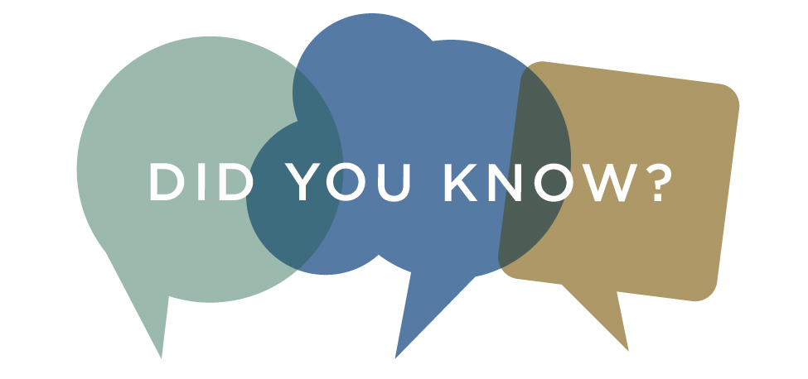

Did you know that there are other ways to get information about the WTBL than just our newsletter? We also have a monthly email where we include information that we think might be of interest to our patrons. Call us if you’d like to sign up. We also have a brand new Facebook page, which you can find by searching for @WorcesterTalkingBookLibrary and liking us.

REFER A FRIEND

Do you know anyone who you think might enjoy our services? Send them our way. If they mention that you referred them to us in their application, we will send you a small thank you gift. We can help to provide services for anyone in Massachusetts.

GO GO GRANDPARENT

We know that finding reliable transportation can be difficult for the low vision community, and sometimes public transit isn’t reliable. One of our patrons was telling us about a service they use called Go Go Grandparent, which is a service that can help seniors find safe reliable transportation for a low monthly fee. For more information, visit gogograndparent.com or call 1-855-464-6872.

CONSUMER ADVISORY BOARD

The Consumer Advisory Board is the group that provides guidance and ideas to the Talking Book Library. The group discusses how to best serve the patrons of the Talking Book Library and the central MA community. We are currently looking for new members and are especially interested in hearing from caretakers of low vision folks, and veterans. To get involved, email us at [talkbook@mywpl.org](mailto:talkbook@mywpl.org).

CONTACT US!

The Talking Book Library is located inside the Worcester Public Library at 3 Salem Square, Worcester, MA. Call us at 508-799-1730 or email us at [talkbook@mywpl.org](mailto:talkbook@mywpl.org) . You can also use the various opportunities that the WPL offers. You can also like us on Facebook. Once we open to the public again, you will be able to visit us to use our technology, pick up and drop off books, or drop in to say hello!

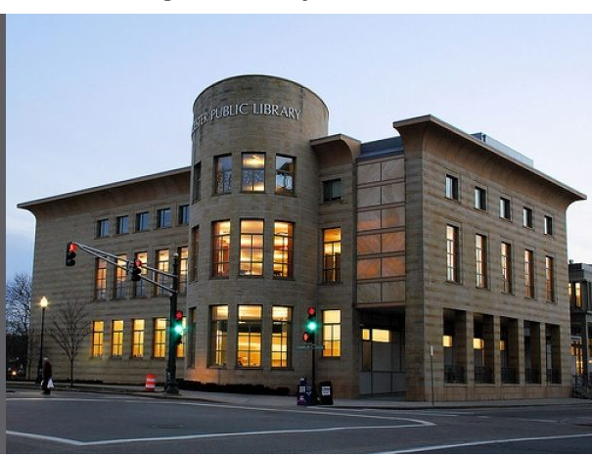

Current hours we are available by phone

Monday-Saturday 9 am - 5:30 pm