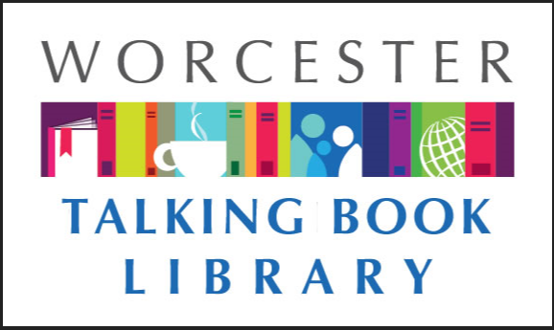
TALKING BOOKLET

Winter 2020 * Worcester Talking Book Library Newsletter

HAPPY NEW YEAR! 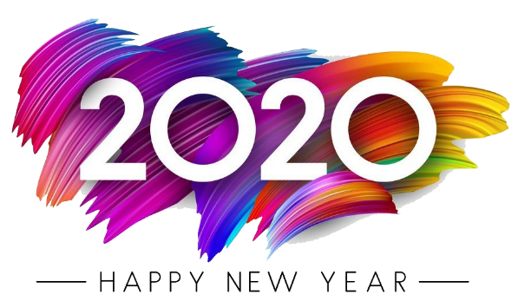
We hope you had a wonderful holiday season and wish you a happy and healthy new year. Talking Books has many exciting things coming this year, so stay tuned! In addition, if you have ideas on how we can serve you better, let us know! We enjoy connecting with our patrons and value your input and ideas.
We would like to thank our good friends at Audio Journal for kindly recording our newsletters for us. For more information on Audio Journal, please visit them at www.audiojournal.org or call 508-797-1117.
If you would prefer to get this newsletter in audio, electronic, or Braille formats, please reach out to us at talkbook@mywpl.org or 508-799-1730, and we will make sure you get what you need as it becomes available.
TBL CREATING A LIBRARY OF THINGS
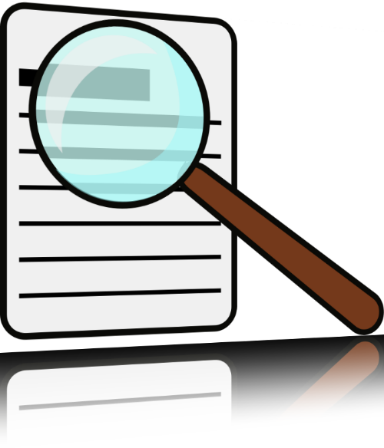
We are excited to announce that we are creating a library of things! We are building a collection of things that we hope will enhance and improve the life experiences of our low vision patrons. Patrons who are members of the Taking Book Library will be able to check out items such as electronic magnifying glasses, games, and braille note takers. We also have braille puzzles for children. For the time being, items must be picked up at our Worcester location, as we have not yet found suitable shipping arrangements. There is a waiver that must be signed to participate in this program, which we can mail to you. This program is still in its infancy, but we are excited to continue to grow it. If you have ideas for things you think would be a great addition to our collection, let us know.

COME TOUCH THE ART!
Talking Books is cosponsoring an event with Audio Journal and ArtsWorcester! On February 20th, join us at ArtsWorcester at 44 Portland Street in Worcester from 12-2pm for a unique immersive experience at the gallery. There will be plenty of art pieces there for you to interact with and touching the art is encouraged. Please bring friends and family, everyone is welcome. Sighted guides will be available to help those with low vision navigate the exhibit. Light refreshments will be available. If you would like to meet at the Worcester Public Library at 11:45am to walk over with a group, you are welcome to do so. We hope to see you there!

CONSTRUCTION IS UNDERWAY
WPL is currently in the throes of the renovation of the main library. We have closed off the Salem Street side entrance as construction crews are currently jackhammering-it’s a bit loud but we are managing fine. The children’s room is moved into its temporary location in one of our function rooms and there are lots of temporary walls up on the first floor. Space is a bit tight, but we are creatively continuing to offer space and services to our patrons.
If you come in and get a bit confused with what is going on, let us know and we can help! We know navigating a space under renovation can be tough for the visually impaired, and we are always here to help.

RECOMMENDED READS
American Sutra: A Story of Faith and Freedom in the Second World War. By Duncan Ryuken Williams. DB94388. A Buddhist priest presents a study of Buddhism in America during World War II. Discusses the practice of the faith under martial law and in interment camps, the treatment of Buddhist solders in combat, and the ways perceived threats to national security undercut the notion of religious freedom. 2019.
The Best of the Best Horror of the Year: 10 Years of Essential Short Horror Fiction. Edited by Ellen Datlow. DB94378. Editor Datlow has selected 28 standout stories from 10 years’ worth of her ‘best of the year’ horror anthologies. Authors include Suzy McKee Charnas, Peter Straub, Laird Barron, Mira Grant, Brian Evenson, and Neil Gaiman. Violence, strong language and some descriptions of sex. 2018.
Black Spring. By Henry Miller. DB92796. More adventures from the Author of The Tropic of Capricorn (DB91271). Recounting his exploits in Brooklyn and Paris, the unnamed protagonist encounters literature and women as he lives the life of a hedonist. Strong language and descriptions of sex. 1963.
Bury the Lead: A Joe Gunther Novel. By Archer Mayor. DB94918. Joe Gunther and his team at the Vermont Bureau of investigations look into the death of a young woman found on a ski mountain. A suspect confesses, but something is off. Meanwhile, the suspect’s ex-employer is being targeted with increasingly dangerous acts of vandalism. Strong language and some violence. 2018.
The Dead Ringer: An Agatha Raisin Mystery. By M.C. Beaton. DB94324, LT24772. As the village prepares for the visit of Bishop Peter Salver-Hinkley, Agatha begins investigating the disappearance of the bishop’s heiress ex-fiancee. Meanwhile, the bodies in the village keep piling up: a policeman, one of a pair of bell-ringing identical twins, and Agatha’s former lover. 2018.
A Dog Named Beautiful: A Marine, a Dog, and a Long Road Trip Home. By Rob Kugler. DB95368, LT26780. Memoir of a US Marine and the dog who was both a companion and comfort in bad times. When his chocolate lab Bella was diagnosed with bone cancer, the author decided to spend the time while they waited for a prognosis on an epic road trip with her. 2019.
Eight Men Out: The Black Sox and the World Series. By Eliot Asinof. DB95616. History of the scandal that erupted in 1919 when eight Chicago White Sox baseball player agreed to throw the World Series. Chronicles the story from the conditions that lead the players to make a deal with gamblers through the famous 1921 trial. 1963.
The Enchanted Land. By Jude Deveraux. DB94225. For Morgan Wakefield to claim the New Mexico ranch she inherited from her father, she must live there a year with her husband. She proposes a marriage of convenience to rancher Seth Colter, only to discover a passion she never expected. Some violence and some descriptions of sex. 1978.
A History of the Bible: The Story of the World’s Most Influential Book. By John Barton. DB95412. Anglican Priest presents a history of the Bible’s creation and provides context for the works included in it. Sections include the Old Testament, the New Testament, the Bible as a whole, and the meanings of the work. Examines its importance to the Jewish and Christian Faith. 2019.
The Killer Across the Table: Unlocking the Secrets of Serial Killers and Predators with the FBI’s Original Mindhunter. By John Douglas and Mark Olshaker. DB95301. FBI criminal profiler and coauthor of Mindhunter (DB43669) delves deep into the lives and crimes of four of the most disturbing and complex predatory killers, offering new details about his profiling process and divulging the strategies used to crack some of America’s most challenging cases. 2019.
Miracle at St. Andrews. By James Patterson and Peter de Jonge. DB94984, LT25938. Travis McKinley is a former professional golfer who feels like he’s an amateur at the ret of life. He makes a pilgrimage to the mythical greens at St Andrews, the course where golf was born, which feels like sacred ground to golfers like Travis. 2019.
Mrs. Everything. By Jennifer Weiner. DB95467, LT26342. Two sisters’ lives unfold against the background of free love, Vietnam, and women’s lib. Bethie becomes an adventure-loving wild child who dives headlong into the counterculture. Meanwhile Jo becomes a proper young mother in Connecticut, a witness to the changing world instead of a participant. Bestseller. 2019.
Natalie Tan’s Book of Luck and Fortune. By Roselle Lim. DB95463, LT26952. Natalie Tan returns to San Francisco ‘s Chinatown when her mother dies only to find her once vibrant street in decline. She learns that she has inherited her grandmother’s long shuttered restaurant and a recipe book and decides to reopen the restaurant and bring life back to the neighborhood. Commercial Audiobook. 2019.
Separate: The Story of Plessy v Ferguson and America’s Journey from Slavery to Segregation. By Steve Luxenberg. DB94863. An account of the 1896 Plessy v Ferguson Supreme Court case that confirmed and protected racial segregation. Draws on letters, diaries, and archival collections to depict the key figures, events and arguments surrounding the case. J. Anthony Lukas Award. 2019.
Run Away. By Harlan Coben. DB94574, LT25819. When Simon finally finds his strung-out college dropout daughter Paige in Central Park, he punches her abusive boyfriend Aaron, but Paige gets away. A few months later, Aaron has been viciously murdered and Simon is frantically trying to find Paige again. Violence and some strong language. 2019.
Unblinded: One Man’s Courageous Journey through Darkness to Sight. By Traci Medford-Rosow and Kevin Coughlin. DB93736. In 1997, thirty-six year old Kevin Coughlin’s eyesight began to blue and within five days he lost his vision. He describes learning he has a genetic disorder called Leber hereditary optic neuropathy and how, fifteen years later, he mysteriously began to regain his sight. Includes journal entries. 2018.

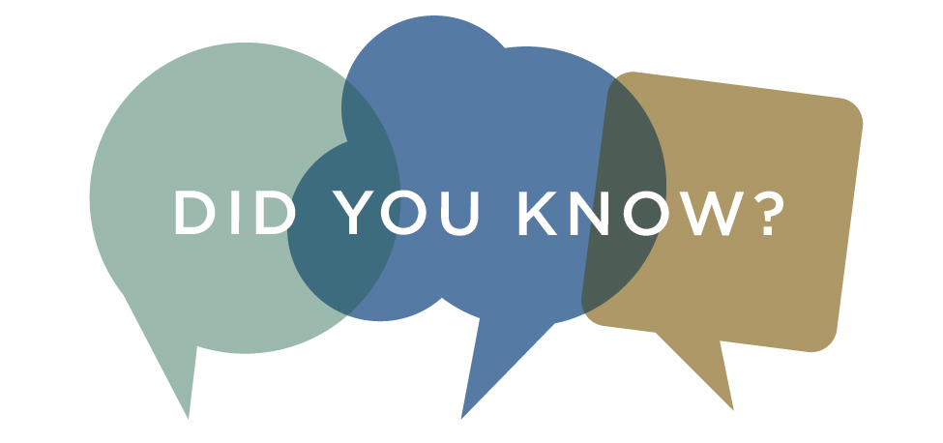
Did you know that we have large type children’s picture books? If you are looking to read with the young people in your life, we can send you books so you can do so. Our reader’s advisors are happy to recommend items that might be of interest. Studies show that reading aloud to young children can help with their attention and behavior. If you are interested in this, contact us today.

INDEX DATABASE CONNECTS PEOPLE WITH SERVICES

INDEX helps people with disabilities in Massachusetts find information they need. Their mission is to improve the lives of people with disabilities and those that serve them - by providing information and referral, technical assistance, training, online education, and technology services.
Their website https://disabilityinfo.org/ provides free information about programs, services, and providers for people with disabilities living in Massachusetts. We also have fact sheets related to disabilities and topics like basic needs, home supports, multicultural resources and recreation.
People can call us with questions about finding disability-related programs or services in Massachusetts at 1-800-624-0249.

2020 IS A CENSUS YEAR

Every ten years the United States of America completes a census. This helps to determine where federal funds and grants are distributed. Completing a census is important and can affect many important decisions for the Commonwealth of Massachusetts.
You can help by participating in the census! They will begin to collect information in March. You can help by responding to them by mail, on the phone, on the internet, or in person. By completing the census, you are not only taking part of an important history that has gone on since 1790, but you are having an impact on future generations.
For more information, visit 2020census.gov.

GREAT EVENTS HAPPENING AT WPL!
There are always many exciting and interesting events happening at the Worcester Public Library. Here are a few upcoming ones:
Computer and Internet for Beginners
(Drop-in) Fridays 9:15-10:45 am. Third Floor Computer Lab. Learn how to use a computer, share documents, search the internet, and access the library website and computers.
Knitting Circle
(Drop In) Thursdays, 3-4 pm. Third Floor Computer Lab. Knit along on a themed project, knit for charity, or bring your own project. Bring your own supplies.
Online Resume Service
Submit a resume and/or cover letter for reviews and editing on our Ask a Librarian page. Please limit each submission to one resume and/or cover letter, and allow up to ten business days for completion of a request.
Seven Bridges Writers’ Collaborative
Wednesdays, 6-8 pm. Third Floor local History Area. Registration required. To register, please call us to at 508-799-1955 ext. 3.
SCORE Small Business Counseling
Second Tuesday of the month 4:30-8:30 pm. Third Floor Study Rooms. One hour with a SCORE counselor. To register, please call us to at 508-799-1955 ext. 3.
Spot the Investment Con and Financial Fraud
Wednesday, February 26th 1-2:30 pm. Third Floor Computer Lab. Learn the tactics that investment scammers use to lure their victims as well as the similar characteristics of common scams so you can “spot the con.” Registration required. To register, please call us to at 508-799-1955 ext. 3.

CONSUMER ADVISORY BOARD

The Consumer Advisory Board is the group that provides guidance and ideas to the Talking Book Library. The group discusses how to best serve the patrons of the talking book library and the central MA community. We are currently looking for new members! To get involved, email us at talkbook@mywpl.org.

CONTACT US!
The Talking Book Library is located inside the Worcester Public Library at 3 Salem Square, Worcester, MA. Call us at 508-799-1730 or 1-800-762-0085, or email us at talkbook@mywpl.org . We are open to the public! We have computers with low vision technology for our patrons to use, and you are able to come in to pick up and drop off books. You can also utilize the various opportunities that the WPL offers. You can also connect with us on Facebook-if you like the Worcester Public Library, we are a closed group within the page.
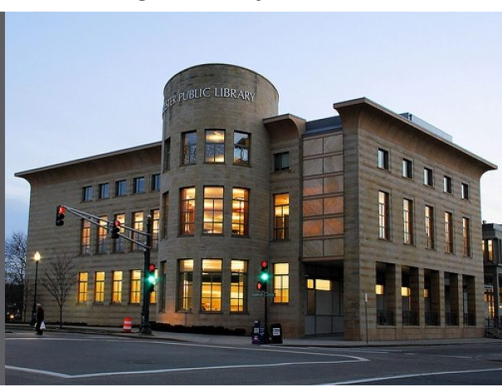

Current hours
Monday-Saturday 9 am - 5:30 pm
Sundays, 1:30-5:30 pm

