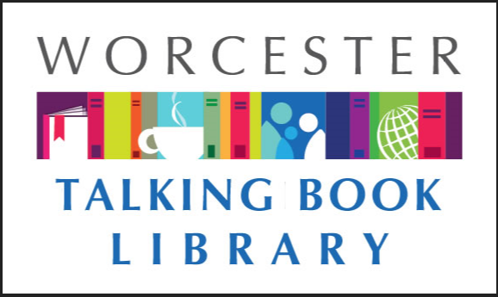
TALKING BOOKLET

Winter, 2019 * Worcester Talking Book Library Newsletter

OUR NEWSLETTER IS BACK!

After a long hiatus, the Talking Book Library at the Worcester Public Library is bringing back our newsletter! Here we will provide information about new books of interest, as well as upcoming and past events that involve the Talking Book Library community. We look forward to bringing you the latest relevant information, and, as always, we want to hear from you! Let us know what sort of information you would like to see.
If you would prefer to get this newsletter in audio, electronic, or Braille formats, please reach out to us at talkbook@mywpl.org or508-799-1730

JIM IZATT RETIRES 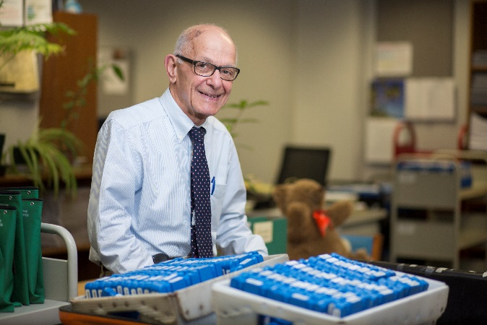

After 25 years as the Head of the Talking Book Library and 50 years working at WPL, Jim Izatt has retired. Jim will be missed by his colleagues, patrons, and friends. He plans on spending his retirement traveling and gardening.
Jim has left some pretty big shoes to fill! Lee Anne Hooley has stepped into the role as Head of Talking Book Services. She has over fifteen years of library experience and is excited to bring it to the Worcester Public Library. To reach Lee Anne, email lhooley@mywpl.org or call 508-799-1621.

WHITE CANE DAY A SUCCESS

On October 16th, the Worcester Public Library hosted White Cane Day, a national event that brings the visually impaired and the sighted together to celebrate and raise awareness on blindness. Several local advocacy groups and the Talking Book Library came together to sponsor and partake in this event.
Sighted people were blindfolded and given a white cane to guide themselves around downtown Worcester, which is currently undergoing a great deal of construction. Sighted guides accompanied them to ensure their safety. Afterwards, they shared their experiences with an audience that included the visually impaired, optometry students, legislation, and general members of the public. The annual event was well attended.
Liz Myska, one of the organizers of the event, said she loved the energy level and participation of the event, and was happy to see sighted people having “a-ha” moments in regards to what it might be like to be visually impaired. “I am still hearing from the participants months after the event, which shows how profound of an affect it had on them,” she said.
In addition, several vendors and organizations were on hand to present information on the latest technology and services available to the visually impaired, as well as the social services and outreach from community organizations. The next White Cane Day is planned for October 2019. 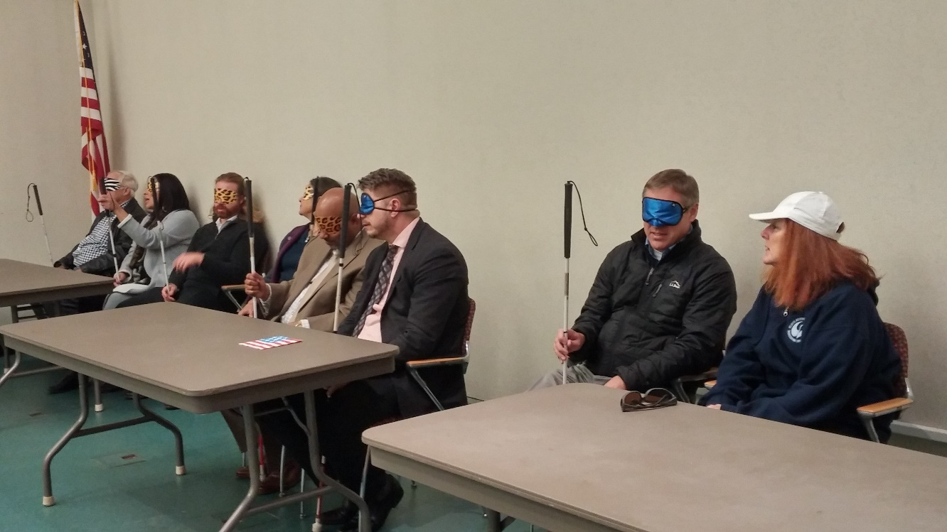
A photo of some of the participants of White Cane Day, still in their blindfolds and holding their white canes, discussing their participation and thoughts on the event.

VISIT OUR NEW WEB PAGE

After close to a decade on the original design, the WTBL is delighted to announce that they have updated their web site. Our accessible site includes a great deal of information. We are constantly working to make it better, and would love some patron feedback. Please visit https://talkingbook.mywpl.org/ today!

RECOMMENDED READS
Looking for something to read? Here are some of our newest acquisitions!
All Summer Long by Dorothea Benton Frank. DB85000, LT20503. A Southern gentleman and his talented New York wife return to his home in the lush Carolina lowcountry, where they endure a summer of transitions while observing the impact of seasonal choices on the lives of neighbors and visitors.
Becoming by Michelle Obama. DB92627, LT24957. A memoir by the former First Lady, the first African American in that role. Obama recounts her childhood in Chicago, her years balancing motherhood and her career as an executive, and her time in the White House. Unrated. Commercial audiobook. Bestseller. 2018.
Beneath a Scarlet Sky by Mark Sullivan. DB90012. Milan, 1943. Teenager Pino Lella becomes involved in the resistance movement to ferry Jews out of Italy. To save him, Pino's family enlists him in the German army. When he is assigned as a driver for General Hans Leyers, Pino begins spying. Violence and some descriptions of sex. Bestseller. 2017.
Bitter Orange by Claire Fuller. LT025261 It is the summer of 1969, and Frances is writing a report on garden architecture in the attic of a dilapidated country house. But she is distracted. The glamorous, hedonistic Peter and Cara are staying in the rooms below, and Frances is surprised to discover that they are keen to spend time with her. Before long they are spending every day together: eating lavish dinners, drinking bottle after bottle of wine, and smoking cigarettes till the ash piles up on the crumbling furniture. But as the summer rolls lazily on, it becomes clear that not everything is right between Cara and Peter. The stories that Cara tells don't quite add up--and as Frances becomes increasingly entangled in their lives, the boundaries between truth and lies, right and wrong, begin to blur. Amid the decadence of that summer, a small crime brings on a bigger one: a crime so terrible that it will brand all their lives forever.
Burning Sky: A Novel of the American Frontier By Lori Benton. DB90335. New York, 1780s. Twelve years after she was abducted by Mohawk Indians and became Burning Sky, Willa Obenchain returns to her family's homestead, where she finds a wounded Scotsman. As she nurses him back to health, she discovers that little is as she left it. Unrated. Commercial audiobook. 2013
City of Saviors by Racheal Howzell Hall. DB90020.
The latest case for LAPD homicide detectives Elouise Norton and her partner Colin Taggert seems straightforward: elderly hoarder Eugene Washington is found dead in his home. But Eugene's four-thousand-member church recently had all the congregants make wills. And some very odd things are discovered in Eugene's house. Some violence and some strong language. 2017.
Defining Moments in Black history: Reading Between The Lies by Dick Gregory. DB90302 Through a series of essays, a civil rights activist examines key moments and subjects in America's black history. Topics include African ancestry, the Middle Passage, the Black Lives Matter movement, the Harlem Renaissance, and more. 2017.
A Few of the Girls by Maeve Binchy. DB83749, LT20016. Maeve Binchy's work has included wonderfully nostalgic pieces along with sharp, often witty writing that is insightful and topical. But at the heart of all her fiction are people and their relationships. A Few of the Girls is a glorious collection of the very best of her stories, full of the warmth, charm, and humor that has always been essentially Maeve.
A Higher Loyalty Truth, Lies and Leadership by James Comey. DB90517. Former FBI director shares lessons and anecdotes from his decades of government service. Includes discussions of specific cases in which he was involved, such as prosecuting the Mafia and Martha Stewart, effecting changes to torture and surveillance policies, and overseeing the Clinton email investigation. Narrated by the author. Unrated. Commercial audiobook. 2018.
The Infinite Future by Tim Wirkus. DB90054. An author, a librarian, and a historian set off to discover the identity of a forgotten Brazilian science fiction author and a fabled manuscript he is purported to have written. Also includes the lost manuscript itself. Unrated. Commercial audiobook, 2018.
John Marshall : the man who made the Supreme Court by Richard Bookhiser. DB093234. An account of the life and work of John Marshall, a Founding Father and the fourth chief justice of the Supreme Court. Discusses Marshall's decades of cases defending the federal government, establishing the rights and powers of the court, and more. Unrated. Commercial audiobook. 2018.
Message from Nam by Danielle Steel. LT21562. Pursuit of a journalism career takes Paxton Andrews from her Savannah, Georgia, home to Berkeley. She falls in love with Peter Wilson, and when he is killed in Vietnam she goes to Saigon as a reporter for the San Francisco Morning Sun, writing a column, "Message from Nam." There she finds a new love, but when he is captured she wonders if she can bear the loss all over again.
A Mother’s Reckoning, Living in the Aftermath of Tragedy by Sue Klebold. DB83764, LT20306. On April 20, 1999, Eric Harris and Dylan Klebold walked into Columbine High School in Littleton, Colorado, killed 12 students and a teacher and wounded 24 before taking their own lives. Since that day, Dylan's mother has lived with indescribable grief and shame. Now, with unflinching honesty, Sue Klebold chronicles her journey as a mother trying to come to terms with the incomprehensible.
The Mystery of the Three Quarters: A new Hercule Poirot Mystery by Sophie Hannah. LT24602. Hercule Poirot returns home after an agreeable luncheon to find an angry woman waiting to berate him outside his front door. Her name is Sylvia Rule, and she demands to know why Poirot has accused her of the murder of Barnabas Pandy, a man she has neither heard of nor ever met. Poirot is equally shocked, because he too has never heard of any Barnabas Pandy, and he certainly did not send the letter in question. He cannot convince Sylvia Rule of his innocence, however, and she marches away in a rage. Shaken, Poirot goes inside, only to find that he has a visitor waiting for him; a man called John McCrodden who also claims to have received a letter from Poirot that morning, accusing him of the murder of Barnabas Pandy... Poirot wonders how many more letters of this sort have been sent in his name: who sent them, and why? More importantly, who is Barnabas Pandy, is he dead, and, if so, was he murdered? And can Poirot find out the answers without putting more lives in danger?
Woman of God by James Patterson and Maxine Paetro. DB86191, LT20832. Scrutinized as the world's first female papal candidate, Brigid Fitzgerald, a doctor on the front lines in Sudan, reflects on her difficult childhood and a series of trials that have tested her faith before a high-stakes battle compels her to convert her enemies to a cause that threatens the Church and her life.

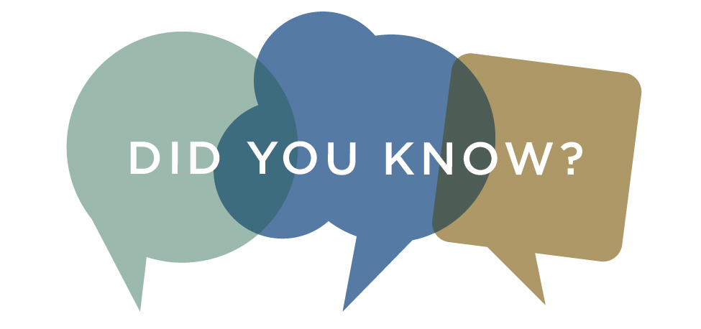
Did you know you can download audiobooks onto your phone? With BARD, you can access scores of titles instantly. For instructions and information, visit https://nlsbard.loc.gov/NLS/instructions.html

GREAT EVENTS HAPPENING AT WPL!
There are always lots of exciting and interesting events happening at the Worcester Public Library. Here are a few upcoming ones:

DIY Crafts for Adults.
Wednesdays, 3-4 pm Banx room
We provide the materials, you provide the creativity. Drop in to try our craft ideas, bring your own crafts to work on, or just stop by to say hi to our crafting community! For ages 16 and up.

eReaders Table
First Thursdays of the Month, 2:15-3:30 pm
Get help downloading free library eBooks to your eReader or smartphone. Bring your device or ask about our devices available for check out. You may also drop-in for eBook and eReader help during library hours.

Language Exchange Café
Saturdays in the café, 9:30-10:30 am
Share your language and culture with a new friend and learn about theirs! Participants will pair up to spend 30 minutes teaching their native language, and then 30 minutes learning their partner's.

Behind the Scenes Tour of the Library
Tuesdays 1-2 pm
Discover things about your library that you never knew! We will meet at the Food for Thought Cafe in the Main Library. No registration required and all are welcome! If you are interested in bringing a group for a tour, please contact vhowley@mywpl.org.
The Commuter Advisory Board is the group that provides guidance and ideas to the Talking Book Library. We are currently looking for new members. To get involved, email us at talkbook@mywpl.org.

CONTACT US!

The Talking Book Library is located inside the Worcester Public Library at 3 Salem Square, Worcester, MA. Call us at 508-799-1730 or 1-800-762-0085, or email us at talkbook@mywpl.org .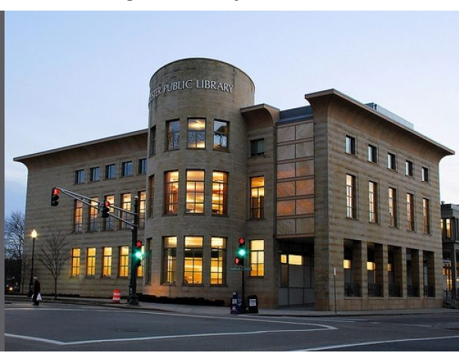

Current hours
Monday-Saturday 9:00 am-5:30 pm
Sunday 1:30-5:30 pm

