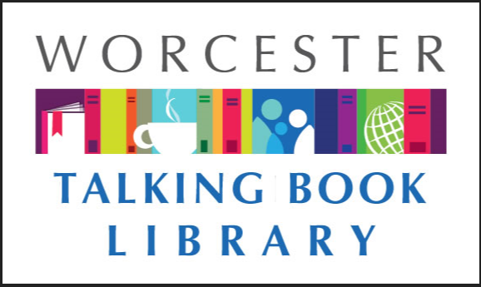
TALKING BOOKLET

Winter 2021 * Worcester Talking Book Library Newsletter
We can’t believe that we are at the end of 2021. It seems like just yesterday it was January and we were making our New Years’ Resolutions. We have seen a lot this year: a renovation, being open again after nearly fifteen months shut down due to the pandemic, and bringing back accessibility workshops. We are optimistic for an even better 2022 for us, and wish our patrons and their loved ones a happy, healthy holiday season.

If you would prefer to listen to this newsletter in audio, call our Dial-A-Story line 508-552-3456 and select menu option #1. For other formats such as braille and email, please reach out to us at talkbook@mywpl.org or 508-799-1730, and we will make sure you get what you need as it becomes available.

AUDIO JOURNAL-RADIO FOR YOU
Audio Journal is a radio reading service for the blind and print disabled. To hear broadcasts, listeners have several options: the new Audio Journal app for iPhone and iPad, smart speaker, computer, telephone, cable TV, or a special receiver tuned to Audio Journal’s frequency. Most programming is available as podcasts on their website and through the Audio Journal app.
Volunteers read newspapers, magazines, books, grocery and retail flyers, and more. The content is designed to be hyperlocal, offering materials from Central MA. Audio Journal reads local periodicals such as: Worcester Telegram & Gazette, newspapers from small communities in Central Massachusetts, books set in New England or by New England authors, Worcester Business Journal, and Vocero Hispano, a statewide Spanish newspaper.
Programs include: Speaking Volumes, a radio book group. All books selected are available at the Worcester Talking Book Library. Listeners may call in and participate in the discussion. There is also Radio-Active Theatre, which broadcasts family-friendly plays from old time radio and film.
Bill, Audio Journal listener and patron of the Worcester Talking Book Library, has a passion for the weather! He reached out to Audio Journal to ask if he could record the daily weather to broadcast to listeners. Bill gets the weather update from the National Weather Service and sends his daily recording to share with Audio Journal listeners. You can usually hear Bill’s weather at 1:57 p.m. after the reading of the Worcester Telegram & Gazette, Monday through Friday on Audio Journal.
If you live in Central Massachusetts and are interested in becoming an Audio Journal listener, please contact Mary Frandsen at mary@audiojournal.org or 508-797-1117.

BORROW A HOT SPOT FROM TBL!
Thanks to a generous grant from the Massachusetts Board of Library Commissioners, TBL patrons can now borrow a hotspot. This will provide you with wireless internet wherever you are! Any patron over the age of seventeen can utilize this service. We will mail the hotspot for you to use for four weeks. You can also come in to visit us and pick one up here. For more information or to request one, call us at 508-799-1730.

DEPOSIT COLLECTIONS AVAILABLE
If your institution (such as a nursing home, senior center, school, or hospital) serves print-disabled individuals, you are eligible to receive hand-delivered deposit collections! These are bags containing large-print or talking books to borrow and circulate among your users. You may borrow a bag for three months, at which time we will visit your facility to pick up the collection and swap it out for a new set of books. For more information, call us today at 508-799-1730.

COVID-19 INFORMATION
There can be a lot of misleading and confusing information on COVID-19 so we want our patrons to know there are reliable ways to keep informed. Some of our favorites are as follows:
Statewide information on COVID-19 can be found at www.mass.gov/covid19 or by calling 211.
In the city of Worcester, resources are available at www.worcesterma.gov/coronavirus or by calling 508-799-1019.
Some cities and towns are offering free COVID-19 tests for Massachusetts residents. For information on locations and scheduling please visit www.mass.gov/info-details/stop-the-spread.
To receive up to date texts about COVID-19 on your cell phone from the Commonwealth of Massachusetts’ coronavirus response team, text 888-777.
The state’s crisis counseling assistance program can be reached at 888-215-4920.
The Massachusetts Nursing Home Family Resource line is 617-660-5399.
NOW OPEN SUNDAYS 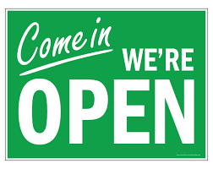

The Worcester Public Library’s Main Branch is now open Sundays. That means TBL is open too! Our staff will be in our first floor public office Sundays from October to April, 12 – 4 pm. You can pick up and drop off books, use our public computers with accessibility features, or just come in to say hello! Hope to see you soon.

VACCINE CLINICS HELD AT THE LIBRARY
The Worcester Public Library is now hosting vaccine clinics at the Main Branch. At this time, clinics run Wednesdays from 11 a.m to 7 p.m. and Saturdays 11 a.m. to 5 p.m. Clinics are operated by the Worcester Department of Health and Human Services and are open to all persons regardless of what town they live in. Anyone 5 and over is eligible. Johnson and Johnson, Moderna, and Pfizer vaccines are available. The clinic will also have booster shots. All vaccines are free regardless of insurance status.

RECOMMENDED READS
Looking for something to read? We always have ideas! Feel free to call us at any time for some suggestions based on your interests.

August Heat. By Andrea Camilleri. DB 100430. When Inspector Montalbano is forced to stay in Vigàta during the August heat, his long-suffering girlfriend, Livia, invites a friend--husband and young son in tow--to keep her company. But when the boy disappears into a narrow shaft hidden under their beach rental, Montalbano uncovers something terribly sinister. Translated from the 2006 Italian. Unrated. Commercial audiobook. 2009.

Betty. By Tiffany McDaniel. DB 100826. Betty, born the sixth of eight children of a Cherokee father and a white mother, grows up in the Ohio hills of the Appalachians. She faces hardships from outside the family and within. To find freedom, she digs deep into her family's past to write of them. Unrated. Commercial audiobook. 2020.

The Evening and the Morning. By Ken Follett. DB 101181, LT 28861.
England, 997. In the time of the Anglo-Saxon kings, Vikings rule the seas. A Norman noblewoman follows her new husband across the sea to her new home. A boat builder moves his family to safety, but doesn't fit in. And a monk dreams of a center of learning. Unrated. Commercial audiobook. 2020.

Hello darkness, My Old Friend: How Daring Dreams and Unyielding Friendship Turned One Man's Blindness into an Extraordinary Vision for Life. By Sanford D. Greenberg DB 100264, BR 23252. Author describes how losing his eyesight as a Columbia junior affected his life trajectory. He went on to Harvard and Oxford and--among many other accomplishments--he invented a compressed speech machine which speeds up the reproduction of words from recordings without distorting any sound. The title reflects his long friendship with Art Garfunkel. 2020.

The House of Kennedy. By James Patterson DB 100060, LT 28155. Bestselling novelist recounts the storied history of the Kennedy family and describes the unique place the Kennedys have occupied in the American imagination across decades and generations. Unrated. Commercial audiobook. Bestseller. 2020.

I Have Something to Tell You : a Memoir. By Chasten Buttigieg. DB 100954. The husband of former mayor Pete Buttigieg reflects on growing up gay in a small Midwestern town, discusses his relationship with Pete, and details his hopes for America's future. Unrated. Commercial audiobook. 2020.

The Midnight Library. By Matt Haig DB 100906, LT 29342, BR 23507.
Between life and death there is a library, and within that library, the shelves go on forever. Every book provides a chance to try another life you could have lived, to see how things would be if you had made other choices. Would you have done anything different, if you had the chance to undo your regrets? Up until now Nora Seed's life has been full of misery. When she finds herself in the Midnight Library, she can now undo every decision she regrets. But things aren't always what she imagined they'd be. 2020.

Stand up Straight and Sing! By Jessye Norman DB 97813. Memoir of renowned African American opera singer. She shares her story of growing up in the segregated South with a family and church community that encouraged her love of music. She also discusses some of the musical pieces important to her and her experiences singing all over the world. 2014.

Squeeze Me. By Carl Hiaasen DB 100606, LT 28761. A prominent Palm Beach dowager is found dead in a concrete grave. Kiki Pew was an ardent fan of the Winter White House resident, and a founding member of the POTUSSIES. The President declares that Kiki was the victim of rampaging immigrant hordes. Meanwhile, there is an influx of huge, hungry pythons. Unrated. Commercial audiobook. Bestseller. 2020.
Their Eyes Were Watching God. By Nora Zeale Hurston. DB 100477, LT 8093, BR 22592. Classic novel of Janie, a handsome black woman, and her three marriages: to Logan Killicks, a prosperous farmer; to go-getter Joe Starks, who makes her Mrs. Mayor Starks of Eatonville, Florida; and to Tea Cake Woods, who teaches Janie, at forty, the reality of love and happiness. 1990 foreword. 1937.

Twilight of the Gods : War in the Western Pacific, 1944-1945. By Ian W. Toll. DB 100956. The author of Pacific Crucible (DB 85019) and The Conquering Tide (DB 83785) examines the final years of World War II in the Pacific. In a narrative style, Toll explores the combat taking place in the air, sea, and beaches, while also discussing the formation of strategy and diplomacy decisions in Washington and Tokyo. Unrated. Commercial audiobook. 2020.

Vesper flights : New and Collected Essays. By Helen Macdonald DB 100529, LT 29341. Author of H Is for Hawk (DB 81386) presents a collection of forty-one essays ruminating on the natural world. Topics include her decision as a young child to become a naturalist, ants, the woods in winter, farming ostriches, and the cycle of life. Unrated. Commercial audiobook. 2020.

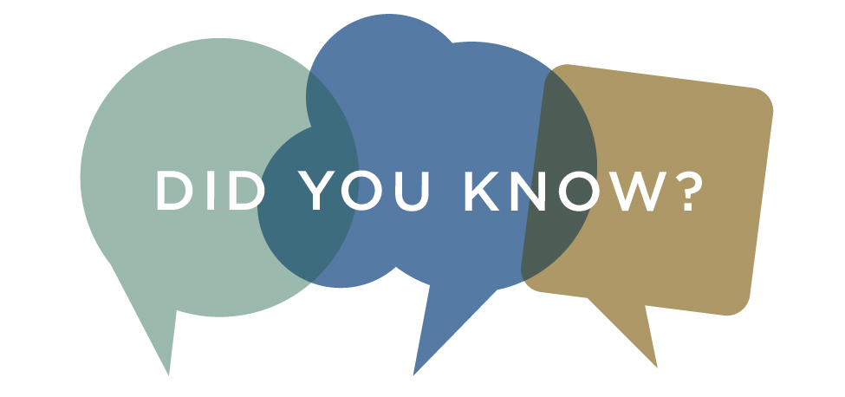
Did you know that the National Federation for the Blind can send your child seasonal letters in braille? You can request either a letter from Santa, or a Winter Celebration letter. These letters include fun activities and are available for children ages ten and younger. For more information, contact the NFB at education@nfb.org or 410-659-9314, ext 2418.

TBL ACCESSIBILITY TRAINING
We are pleased to offer the following accessibility training workshops at the Worcester Public Library’s Main Branch. All classes are from 10-11 a.m. and will be held in the First Floor Computer Lab, located in the Newspapers and Magazines section. Special thanks to Donna and Nona, our trainers!
December 16 Basic use of the Mail App
January 20 Using Siri as your personal assistant
February 17 How to use the on screen keyboard and dictation

WPL PROGRAMS
Worcester Public Library is providing programs in both in person and virtual formats. Here is a list of a few upcoming events that we wanted to share.
An R means reservations are required. Call 508-799-1725 to make sure you have a space.

Intro to Meat Substitutes with Colin McCullough*(R) Saturday, Jan. 15 2:30 - 4 p.m. Saxe Room
Learn about the latest options and how to make your own!

Introduction to Self-Publishing with Diane V. Mulligan*(R) Saturday, Feb. 19 11 a.m. - 12 p.m. First Floor Computer Lab/Zoom
An overview of self-publishing.
La Borinqueña: An Icon of Hope, Social Justice, & Philanthropy with Edgardo Miranda-Rodriguez*(R)
Saturday, Jan. 8 11 a.m. - 12 p.m. Zoom
Miranda-Rodriguez will discuss how he created La Borinqueña to bring social justice issues to light and create an icon for an underrepresented community.

Research Your Family Myths and Legends (R)
Saturday, Dec. 184 - 5 p.m. Zoom
Join us as we discuss how to research your family legends.

A Virtual Tour of African American Artists with the Worcester Art Museum (R)
Saturday, Feb. 19 2:30 - 3:30 p.m. Zoom
Go on a virtual tour with WAM to explore the works of six artists. Ages 16+.

CONTACT US!
The Talking Book Library is located inside the Worcester Public Library at 3 Salem Square, Worcester, MA. Call us at 508-799-1730 or email us at talkbook@mywpl.org. You can also like us on Facebook. We have a monthly email list as well that you can request to receive. We are open to the public for circulation and computer use, so please come by and say hello!
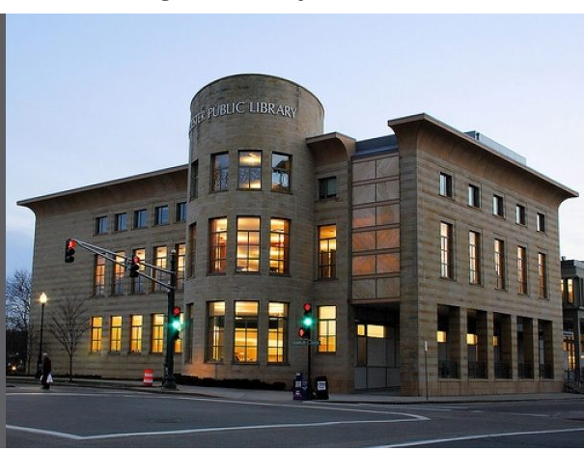

Monday-Saturday
9 - 10:30 a.m.
11 a.m. - 12:30 p.m.
1 - 2:30 p.m.
3 - 4:30 p.m.
Sunday
12 p.m – 4 p.m.

