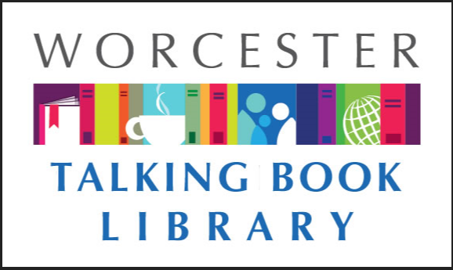 TALKING BOOKLET

Spring 2020 * Worcester Talking Book Library Newsletter

SPRING HAS SPRUNG 

We hope our latest newsletter finds you in good health, especially after such a challenging few months. At the time of print, the Talking Book Library is not physically open and therefore unable to send books out via the mail. We are hoping to get the doors open soon, but this newsletter will feature some information that we hope you can use.

We would like to thank our good friends at Audio Journal for kindly recording our newsletters for us. For more information on Audio Journal, please visit them at www.audiojournal.org or call 508-797-1117.

If you would prefer to get this newsletter in audio, electronic, or Braille formats, please reach out to us at [talkbook@mywpl.org](mailto:talkbook@mywpl.org) or 508-799-1730, and we will make sure you get what you need as it becomes available.

COVID-19 SHUTS THE WTBL’S SPACE

Due to mandates put in place by Governor Baker, the Worcester Talking Book Library had to shut their doors on March 25th until further notice. While we were sad with the decision, we recognize the most important thing any of us can do is to stay home whenever possible to help prevent the spread of the virus. Talking Book employees are working remotely and answering emails Monday-Friday. While we cannot send out any physical books for the time being, we are here to help our patrons in whatever ways that we can.

The situation with COVID-19 is changing rapidly, and we are trying our best to keep current with the situation. We encourage our patrons to do the same! The City of Worcester has created a hotline with up-to- date and current information. You can call them at 508-799-1019. Massachusetts also has a lot of information on its web site, which can you can access at [www.mass.gov/covid19](http://www.mass.gov/covid19)

WE ARE STILL HERE TO HELP! 

There are still lots of options that you have even if we are unable to send books out right now. If you have a smart phone or a tablet, you can listen to talking books whenever you’d like, wherever you’d like! For information on how to apply, you can email us at [talkbook@mywpl.org](mailto:talkbook@mywpl.org).

Are you interested in reading e-books on your tablet or e-reader? We can help with that too! Many public libraries offer a diverse array of titles to borrow. With an e-reader, you can take any book and make it large type! The Worcester Public Library is offering virtual reference help on their web site specifically designed for people with questions about using an e-reader. You can visit [www.mywpl.org](http://www.mywpl.org) for more information.

In addition, we are offering services on our Facebook Pages! Both the Worcester Talking Book Library and the Worcester Public Library have a Facebook presence, where we are offering everything from virtual story times for kids and adults, to fun activities you can do at home. All you have to do is search for the Worcester Talking Book Library and request to join our group, or Like the Worcester Public Library and request to be added that way.

CONSTRUCTION UPDATE 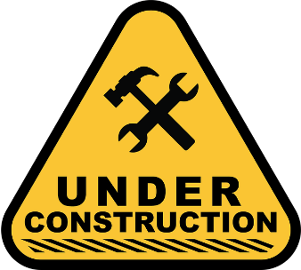

Prior to the library closing, the library renovation was going well! The construction team has broken through where the new front door will be, and are working on creating new spaces for areas such as an innovation centerand improved meeting spaces.

RECOMMENDED READS

*The Body: A Guide for Occupants*. By Bill Bryson. **DB96770, LT27150**  
Guides readers through the human body—how it functions, its remarkable ability to heal itself, and the ways it can fail. Using facts—your body made a million red blood cells since you started reading this—and anecdotes, creates a deeper understanding of the miracle that is you. Unrated. Commercial audiobook. 2019.

*Brandiron,* Books 1-6. By Dusty Richards **DB91396**   
Six westerns, written between 2015 and 2017. Includes A Bride for Gil, The Mustanger and the Lady, The Texas Badge, The Cherokee Strip, Gold in the Sun, and The Pride of Texas, in which twin boys—orphaned by a murder-suicide—are raised by a widowed female cousin in the Wild West. Violence and strong language. 2017

*Country Music: A History*. By Dayton Duncan and Ken Burns. **DB96527**  
Companion to the PBS documentary series chronicles country music from its roots in the American South to the modern commercial successes of the genre, which encompasses a wide range of sounds and styles. Profiles and interviews some of country’s biggest stars. Unrated. Commercial audiobook. 2019.

*Dancing with Bees: A Journey Back to Nature*. By Brigit Strawbridge Howard **DB96942**  
Naturalist recounts her exploration into the world of bees—including the day she realized she knew more about the French Revolution than she did about the species. Discusses the behavior of bees, environmental needs for their success, and impact on humans. 2019.

*The Dutch House.* By Ann Patchett. **DB96739, LT26923**  
Through a canny investment at the end of World War II, Cyril Conroy lifts his family out of poverty. His first order of business is to buy the lavish Dutch House. But this purchase brings only heartache to his loved ones—including children Danny and Maeve. Unrated. Commercial audiobook. 2019.

*Enemies in Love: A German POW, a Black Nurse, and an Unlikely Romance.* By Alexis Clark **DB97265**  
An account of the forbidden romance between African American nurse Elinor Powell in the US military and Nazi soldier Frederick Albert, a prisoner of war at an Allied camp. Draws on years of interviews and historical research. 2018.

*Harlem Renaissance: Four Novels of the 1930s*. Edited by Rafia Zafar. **DB91302**  
Four novels from African American writers during Harlem’s cultural and artistic movement of the 1930s. Includes Not without Laughter by Langston Hughes, Black No More by George S. Schuyler, The Conjure-Man Dies by Rudolph Fisher, and Black Thunder by Arna Bontemps. Some violence and some strong language. 2011.

*Have You Seen Luis Velez?* By Catherine Ryan Hyde. **DB96316**  
Teenager Raymond leads a lonely life, shuttling between the homes of his divorced parents. Millie, an elderly blind woman who lives in his mother’s building, asks him if he has seen the man who was her caretaker. He starts helping Millie, and looking for the missing Luis Velez. 2019.

*Les Misérables.* By Victor Hugo. **DB96732**  
Jean Valjean, a poor French peasant, is imprisoned for stealing a loaf of bread to feed his sister’s hungry children. He escapes, hiding his identity and devoting his life to noble causes, until he once again becomes the victim of cruel circumstance in early nineteenth-century France. Commercial audiobook. 2008.

*The Loyal One.* By Shelley Shepard Gray **DB96733**, **LT26789**  
Katie Steury hires her old friend Harley Lambright to remodel her rundown old house into a charming bed and breakfast in the Amish community of Walnut Creek. Though they are longtime friends, they have a rocky relationship, thanks to her being partly responsible for his most recent breakup. Unrated. Commercial audiobook. 2019.

*Nine Perfect Strangers*. By Liane Moriarty **DB92901 LT24914**  
Nine people gather at a remote health resort called Tranquillum House, each for their own reasons. Among them is Frances, a romance novelist who is intrigued by both her fellow guests and the charismatic owner, while fighting the feeling she should run while she still can. Unrated. Commercial audiobook. 2018.

*Nothing Ventured*. By Jeffery Archer **DB96828** **LT26944**  
William Warwick, the protagonist of the books written by Harry Clifton from *Only Time Will Tell* **(DB73852, LT12637**), fights with his lawyer father over his dream of becoming a detective. He eventually joins the Metropolitan Police and is assigned to investigate art crimes. Unrated. Commercial audiobook. 2019.

*Olive, Again*. By Elizabeth Strout **DB97052, LT27072**  
This collection of linked stories follows the cantankerous Olive Kitteridge as she struggles to understand not only herself and her own life, but the lives of those around her in her Maine hometown. Sequel to *Olive Kitteridge* (**DB67392, LT11914**). Some strong language. Commercial audiobook. 2019.

*Stealth.* By Stuart Woods **DB97005,** **LT27162**  
Stone Barrington is enjoying some downtime at his English retreat when he’s unceremoniously sent off to the remote reaches of the UK and into a deadly snare. This is only the first volley by a rival power—one that has its eyes set on disrupting the peace of the nation. Unrated. Commercial audiobook. 2019.

*Unexpectedly Eighty and Other Adaptations; Nearing Ninety and Other Comedies of Late Life* By Judith Viorst. **DB96277**   
Two books of humorous poetry on aging written in 2010 and 2019 by the author of *Suddenly Sixty* (**DB62118**) and *I’m Too Young to Be Seventy* (**DB62480**). “The Graduation Brunch” muses on the family members you reconnect with at special events. 2019.

*The Water Dancer.* By Ta-Nehisi Coates **DB96729**, **LT26928**  
Born into bondage, Hiram Walker is robbed of all memory of his mother when she is sold. But Hiram is blessed with a mysterious power. This power saves him when he almost drowns, and he knows he must escape the only life he has ever known. Violence. Commercial audiobook. 2019.

*A Willing Murder*. By Jude Deveraux **DB92708, LT27421**    
Retired romance author Sara Medlar, her previously estranged niece Kate, and irritating Jackson Wyatt make unlikely roommates in Sara’s newly acquired mansion in Lachlan, Florida. When two skeletons are accidentally uncovered in the quiet town, the trio decides to work together to solve the mystery. Unrated. Commercial audiobook. 2018.

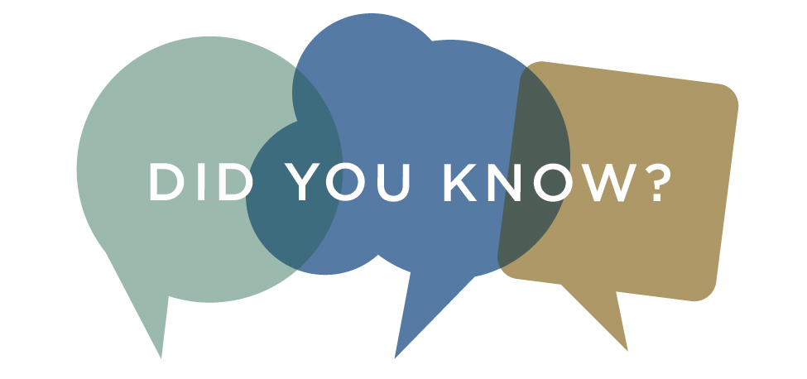

Did you know that we send a list of new large type books every month to our large type readers? This way you can see what we have and select books you might be interested in reading. In addition, we archive older lists on our web site. You can find them at talkingbook.mywpl.org. And remember: we have more than just the current lists-if there is an author or a genre you are interested in reading, just let us know.

TACTILE ART EXHIBIT A SUCCESS

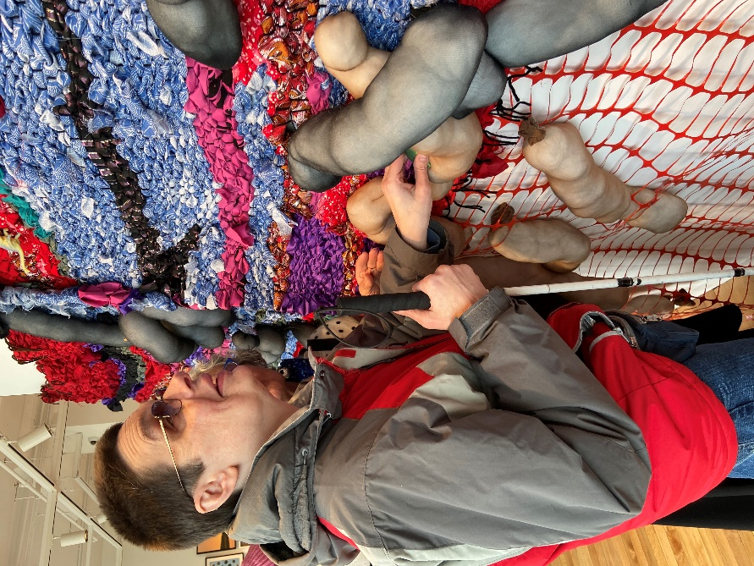 (A photo of Bill, a regular visitor to the Talking Book Library, touching a large sculpture which is mounted to a wall. The sculpture includes fabric and plastic elements)

*We had a wonderful time on February 20th at a tactile art exhibit, but don’t take our word for it! Here is an essay written by Sharon Strazalkowski, TBL board member, about her experiences at the exhibit.*

An Adventure in Tactile Art

By Sharon Strzalkowski

I was recently privileged to participate in a new venture cosponsored by the Worcester Talking Book Library and Audio Journal, part of the Talking Information Network. These two organizations teamed up with ArtsWorcester to present an exhibit of touchable art for those of us with little or no vision to enjoy.

Arts Worcester has been in its current luxurious space for a couple of years, and honestly, it was not a place that I thought I had any reason to visit. But on this day, I and some other 20 people were greeted by the Worcester Arts director and very enthusiastic and knowledgeable volunteer guides. It is a rare experience to have a one-on-one guide in such a setting, but that’s what I had, and it was wonderful!

Much of the tactile art was combinations of textures such as puffy cottons and quilts to stand for clouds, and then weavings of various kinds to stand for other aspects of nature. My guide said that this was modern interpretative art, and it seemed very much to me like some modern music that I have heard where there is ever-changing rhythm, key change and little sense of what the foundation is.

I was particularly fascinated by one sculpture of a face, and realized in a visceral way that features on a human face can vary a lot from my own. Never having been able to see, this was somewhat of a revelation, even though I knew it in my head. I also touched some cutout figures, and one was of a ballerina and I could get the idea of the position that she was in.

An exciting part of the day was learning that future exhibits would be coming with at least some touch component. I and many others signed up for the Arts Worcester email newsletter, and look forward to continuing the relationship with this worthy organization. My thanks to Worcester Talking Book Library and Audio Journal for taking the step of forging a relationship with Arts Worcester.

CONSUMER ADVISORY BOARD

The Consumer Advisory Board is the group that provides guidance and ideas to the Talking Book Library. The group discusses how to best serve the patrons of the Talking Book Library and the central MA community. We are currently looking for new members! To get involved, email us at [talkbook@mywpl.org](mailto:talkbook@mywpl.org).

CONTACT US!

The Talking Book Library is located inside the Worcester Public Library at 3 Salem Square, Worcester, MA. Call us at 508-799-1699 or email us at [talkbook@mywpl.org](mailto:talkbook@mywpl.org) . You can also utilize the various opportunities that the WPL offers. You can also connect with us on Facebook-if you like the Worcester Public Library, we are a closed group within the page. Once we open to the public again, you will be able to visit us to use our technology, pick up and drop off books, or drop in to say hello!

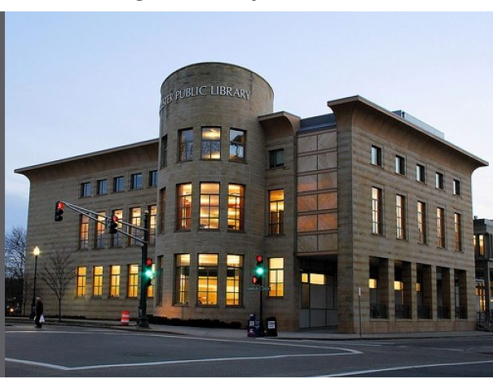

Current hours

Monday-Saturday 9 am - 5:30 pm

Sundays, 1:30-5:30 pm